**MINI PROJECT**

on

**Explore.com**

Submitted for partial fulfillment of the requirements for the award of the degree

of

**BE 2/4 (CSE) MINI PROJECT**

**BY**

**V.ANJANI (160115733064)**

**B.SRAVYA (160115733076)**

Under the guidance of

**I.SRUJANA**

Assistant professor

Department of CSE

CBIT, Hyderabad.

**T.SRIDEVI**

Assistant professor

Department of CSE

CBIT, Hyderabad



**Department of Computer Science and Engineering**

**Chaitanya Bharathi Institute of Technology**

**Gandipet, Hyderabad – 500075**

**CERTIFICATE**

This is to certify that the project work entitled “**Explore.com**” is bonafide work carried out by **V.Anjani**(160115733064),**B.Sravya**(160115733076) in fulfillment of the requirements for the award of degree of **BACHELOR OF ENGINEERING IN COMPUTER SCIENCE AND ENGINEERING** by the **OSMANIA UNIVERSITY**, Hyderabad, under our guidance and supervision .

The results embodied in this report have not been submitted to any other university or institute for the award of any degree or diploma.

Internal Guide, Head of Department

A.Mohan Dr.Y.Rama devi

Assistant Professor Professor and Head

Department of CSE Department of CSE

CBIT, Hyderabad. CBIT, Hyderabad.

**DECLARATION**

This is to certify that the work reported in the present project entitled “**Explore.com**” is a record of work done by us in the Department of Computer Science and Engineering. Chaitanya Bharathi Institute of Technology, Osmania University. The reports are based on the project work done entirely by us and not copied from any other source.

V.Anjani

(160115733064)

B.Sravya

(160115733076).

**ACKNOWLEDGEMENTS**

We would like to express our deep felt appreciation and gratitude to **Explore.com**, Associate Professor, Department of CSE ,my project guide ,for his skillful guidance, constant supervision, timely suggestion ,keen interest and encouragement in completing the mini project in stipulated time.

We are honored to express our profound sense of gratitude to **Dr.Y.Ramadevi,** Head of Department,CSE, who has served as host of valuable corrections and for providing us time and amenities to complete this project.

We gratefully express our thanks to Dr.ChennaKeshava Rao, Principal of our college and the management of **“CHAITANYA BHARATHI INSTITUTE OF TECHNOLOGY”** for providing excellent academic and learning environment in the college.

We wish to express our heartfelt gratitude to the **Members of Staff** and all others who helped us in bringing up our project. We would also like to thank the **Lab assistants** and Programming for helping us through our project.

V.Anjani

(160115733064),

B.Sravya

(160115733076).

**ABSTRACT**

It happens many a times that we are new to a city and we have no knowledge of the frame of that place. Gathering the information about your new environment is quite an arduous task. In today's world anything could be known within seconds through internet. But we still have trouble in gathering the whole information we search for. Many atimes we do not get the exact information about that place at a single go or at once even after searching in the internet and also asking different people about it. We are not sure that we can get the exact and complete information from them.

This project aims at developing such a web page which provides you the complete information about the tourist places, colleges, universities, schools, airports, railway stations, hospitals, banks in the city along with their address, contact details and their websites. It acts like a perfect guide to explore the city. People need not login the website to have access. Thus, this project aims at providing an easier access to the new environment.

.

**TABLE OF CONTENTS**

**Name of the topic Page No**

Certificate 2

Declaration 3

Acknowledgements 4

Abstract 5

**1. INTRODUCTION 8**

1.1 Objectives

1.2 Limitations

**2. LITERATURE SURVEY 9**

2.1 Languages used

2.2 Benefits

2.3 Modules

**3. SYSTEM REQUIREMENTS 10**

3.1 Hardware requirements

3.2 Software requirements

**4. FLOW CHART 11**

**5. IMPLEMENTATION 12**

5.1 HOME.html

5.2 DELHI.html

5.3 TOURISTDELHI.html

5.4 AIRPORTSDELHI.html

5.5 RAILWAYSTATIONSDELHI.html

5.6 EDUCATIONDELHI.html

5.7 HOSPITALDELHI.html

5.8 BANKSDELHI.html

5.9 ABOUT.html

**6. RESULTS & DISCUSSIONS 57**

6.1 Home page

6.2 Delhi

6.2.1 Tourist places

6.2.2 Airports

6.2.2.1 Redirecting website

6.2.3 Railway Stations

6.2.4 Education

6.2.5 Hospitals

6.2.6 Banks

6.3 Hyderabad

6.4 Chennai

6.5 Mumbai

6.6 Bengaluru

6.7 About

**7. CONCLUSION s81**

**\* REFERENCES**

**Chapter-1**

**INTRODUCTION**

**1.1 OBJECTIVES**

Explore.com, is a website which gives an idea over an unknown city. This is specially designed for people when they are new to a city and need guidance regarding the place. For example if a person wants to know about the best hospital in the city, then when he access this website he not only gets information about the name of the hospital but also the address, contact details and the official website. The user no need to login or register to get access to the website information. User is not forced to share any of his information.

**1.2 LIMITATIONS**

Our project has the following limitations:-

1. The website is limited to only few cities.

2. The information regarding only a few components were included.

**Chapter -2**

**LITERATURE**

**2.1 LANGUAGES USED**

* HTML [Hyper Text Markup Language].
* CSS [Cascading Style Sheets].
* Java Script.

**2.2 BENEFITS**

* Everything is available at one place.
* Easily accessible through internet.
* Takes very less time.
* All in one guide.
* It’s panoptic(at one view).

**2.3 MODULES**

* Module 1: CITIES

In this module the names of the cities whose details are available in the website are listed. This is also can be considered as the home page of the website.

* Module 2: AREA OF INTEREST

When the user clicks on a city available from the above module he will be directed to a page in which different areas are listed. Like regarding what the details are provided in this module.

* Module 3: DETAILS

When the user selects an area or field among the given options in the above module the details of that particular option will be displayed in this module.

* Module 4: REDIRECTING WEBSITE

Along with the other information official website link is also provided which directs to the website directly when selected.

**Chapter-3**

**SYSTEM REQUIREMENTS**

**3.1 HARDWARE REQUIREMENTS**

1. Intel core i3 2nd generation is used as processor because it is faster & provide reliable and stable working environment.

2. A RAM size of 350MB is used as it will provide fast reading & writing capabilities.

**3.2 SOFTWARE REQUIREMENTS**

Front end: HTML

Operating system: Windows professional.

**Chapter 4**

**FLOW CHART**

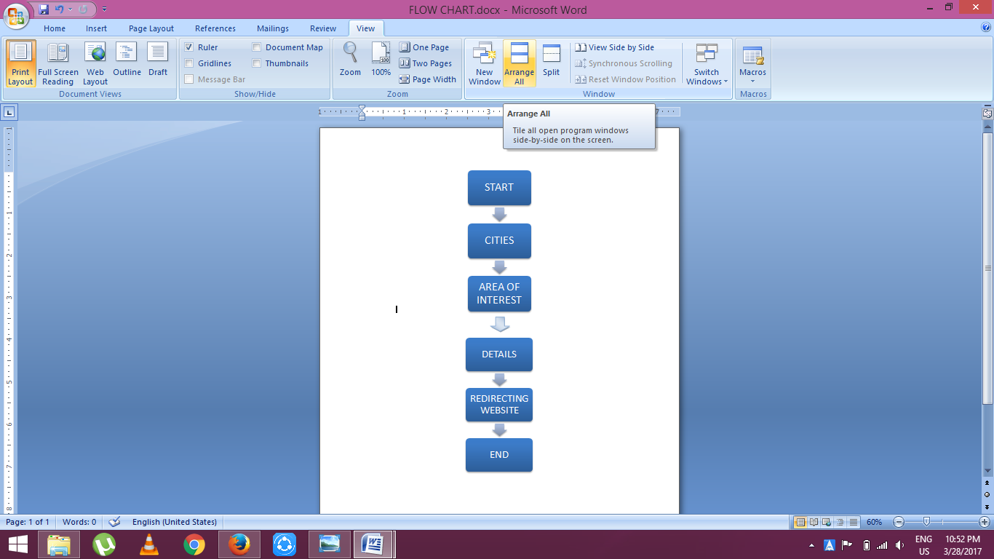

**Chapter 5**

**IMPLEMENTATION**

**5.1. HOME.html**

<!DOCTYPE html>

<html>

<head>

<meta name="viewport" content="width=device-width, initial-scale=1">

<meta charset="UTF-8">

<meta name="viewport" content="width=device-width, initial-scale=1">

<link rel="stylesheet" type="text/css" href="sample.css">

<style>

* {box-sizing:border-box}

body {font-family: Verdana,sans-serif;margin:0

}

body{

background-image:url("new.jpg");

background-size: 100% 100%;

//background-repeat: no-repeat;

}

.mySlides {display:none}

/* Slideshow container */

.slideshow-container {

max-width: 700px;

position: relative;

margin: auto;

}

/* Next & previous buttons */

.prev, .next {

cursor: pointer;

position: absolute;

top: 50%;

width: auto;

padding: 16px;

margin-top: -22px;

color: white;

font-weight: bold;

font-size: 18px;

transition: 0.6s ease;

border-radius: 0 3px 3px 0;

}

/* Position the "next button" to the right */

.next {

right: 0;

border-radius: 3px 0 0 3px;

}

/* On hover, add a black background color with a little bit see-through */

.prev:hover, .next:hover {

background-color: rgba(0,0,0,0.8);

}

/* Caption text */

.text1 {

color:white;

font-size: 15px;

padding: 8px 12px;

position: absolute;

bottom: 8px;

width: 100%;

text-align: center;

}

.text2 {

color:black;

font-size: 15px;

padding: 8px 12px;

position: absolute;

bottom: 8px;

width: 100%;

text-align: center;

}

/* Number text (1/3 etc) */

.numbertext {

color: #f2f2f2;

font-size: 12px;

padding: 8px 12px;

position: absolute;

top: 0;

}

/* The dots/bullets/indicators */

.dot {

cursor:pointer;

height: 13px;

width: 13px;

margin: 0 2px;

background-color: #bbb;

border-radius: 50%;

display: inline-block;

transition: background-color 0.6s ease;

}

.active, .dot:hover {

background-color: #717171;

}

/* Fading animation */

.fade {

-webkit-animation-name: fade;

-webkit-animation-duration: 1.5s;

animation-name: fade;

animation-duration: 1.5s;

}

@-webkit-keyframes fade {

from {opacity: .4}

to {opacity: 1}

}

@keyframes fade {

from {opacity: .4}

to {opacity: 1}

}

/* On smaller screens, decrease text size */

@media only screen and (max-width: 300px) {

.prev, .next,.text {font-size: 11px}

}

</style>

</head>

<body>

<!-- Navigation -->

<ul>

<li><a href="new1.html">Home</a></li>

<li><a href="delhi.html">Delhi</a></li>

<li><a href="hyderabad.html">Hyderabad</a></li>

<li><a href="chennai.html">Chennai</a></li>

<li><a href="mumbai.html">Mumbai</a></li>

<li><a href="bengaluru.html">Bengaluru</a></li>

<li><a href="about.html">About</a></li>

</ul>

<div class="slideshow-container">

<div class="mySlides fade">

<img src="lotus temple2.jpg" style="width:100%">

</div>

<div class="mySlides fade">

<img src="HYD6.jpg" style="width:100%">

</div>

<div class="mySlides fade">

<img src="mumbai.jpg" style="width:100%">

</div>

<div class="mySlides fade">

<img src="chennai2.jpg" style="width:100%">

</div>

<div class="mySlides fade">

<img src="bang1.jpg" style="width:100%">

</div>

<a class="prev" onclick="plusSlides(-1)">&#10094;</a>

<a class="next" onclick="plusSlides(1)">&#10095;</a>

</div>

<br>

<div style="text-align:center">

<span class="dot" onclick="currentSlide(1)"></span>

<span class="dot" onclick="currentSlide(2)"></span>

<span class="dot" onclick="currentSlide(3)"></span>

<span class="dot" onclick="currentSlide(4)"></span>

<span class="dot" onclick="currentSlide(5)"></span>

</div>

<script>

var slideIndex = 1;

showSlides(slideIndex);

function plusSlides(n) {

showSlides(slideIndex += n);

}

function currentSlide(n) {

showSlides(slideIndex = n);

}

function showSlides(n) {

var i;

var slides = document.getElementsByClassName("mySlides");

var dots = document.getElementsByClassName("dot");

if (n > slides.length) {slideIndex = 1}

if (n < 1) {slideIndex = slides.length}

for (i = 0; i < slides.length; i++) {

slides[i].style.display = "none";

}

for (i = 0; i < dots.length; i++) {

dots[i].className = dots[i].className.replace(" active", "");

}

slides[slideIndex-1].style.display = "block";

dots[slideIndex-1].className += " active";

}

</script>

<!-- Website Description -->

<center>

<h1><b><font face="Jokerman" size="20" color="#f2f2f2">Explore.com</font></b></h1>

</center>

</section>

</body>

</html>

**5.2. DELHI.html**

<!DOCTYPE>

<html>

<head>

<title>delhi</title>

<meta name="viewport" content="width=device-width, initial-scale=1">

<meta charset="UTF-8">

<meta name="viewport" content="width=device-width, initial-scale=1">

<link rel="stylesheet" type="text/css" href="sample.css">

<style>

body{

font-family: Verdana,sans-serif;margin:0;

}

body{

background-image:url("aak.jpg");

background-size: 100%100%;

background-repeat:no-repeat;

}

h1{

font-family:Bradley Hand ITC;

}

.button {

background-color: white;

border: black;

color: black;

padding: 16px 32px;

text-align: center;

text-decoration: none;

display: inline-block;

font-size: 16px;

margin: 4px 2px;

border-radius: 20px;

-webkit-transition-duration: 0.4s; /* Safari */

transition-duration: 0.4s;

cursor: pointer;

}

.button{

background-color: #555555;

color: white;

border: black;

}

.button:hover {

background-color:white;

color: black;

}

</style>

</head>

<body>

<!-- Navigation -->

<ul>

<li><a href="new1.html">Home</a></li>

<li><a href="delhi.html">Delhi</a></li>

<li><a href="hyderabad.html">Hyderabad</a></li>

<li><a href="chennai.html">Chennai</a></li>

<li><a href="mumbai.html">Mumbai</a></li>

<li><a href="bengaluru.html">Bengaluru</a></li>

<li><a href="about.html">About</a></li>

</ul>

<center>

<h1><b>WELCOME TO DELHI</b></h1>

</center>

<h2><i>WHAT DO YOU WANT?</i></h2>

<h3>HERE IS SOME INFORMATION ABOUT THE CITY .....TO GET ON WITH IT!!!</h3>

<center>

<a href="touristdelhi.html" class="button ">TOURIST PLACES </a>

<a href="airportsdelhi.html" class="button">AIRPORTS</a>

<a href="railwaydelhi.html" class="button">RAILWAY STATIONS </a>

<a href="educationdelhi.html" class="button">EDUCATION</a>

<a href="hospitalsdelhi.html" class="button">HOSPITALS</a>

<a href="banksdelhi.html" class="button">BANKS</a><br/>

</center>

</body>

</html>

**5.3. TOURISTDELHI.html**

<!DOCTYPE>

<html>

<head>

<title>tourist places -delhi</title>

<meta charset="UTF-8">

<meta name="viewport" content="width=device-width, initial-scale=1">

<link rel="stylesheet" type="text/css" href="sample.css">

<style>

body{

background-image:url("back3.jpg");

background-size: 100% 100%;

background-repeat: no-repeat;

font-family: Verdana;margin:0;

}

h1{

text-align:center;

font-family:Cooper Black;

font-size:40px;

}

h3{

font-family:Comic sans MS;

font-size:30px;

}

pre{

font-family:AR JULIAN;

font-size:20px;

}

</style>

</head>

<body>

<!-- Navigation -->

<ul>

<li><a href="new1.html">Home</a></li>

<li><a href="delhi.html">Delhi</a></li>

<li><a href="hyderabad.html">Hyderabad</a></li>

<li><a href="chennai.html">Chennai</a></li>

<li><a href="mumbai.html">Mumbai</a></li>

<li><a href="bengaluru.html">Bengaluru</a></li>

<li><a href="about.html">About</a></li>

</ul>

<h1>TOURIST PLACES</h1>

<h3 >Red Fort</h3>

<pre>

Netaji Subhash Marg, Lal Qila,<br/>

Chandni Chowk, New Delhi, Delhi<br/>

110006<br/>

Ph:011 2469 8431

</pre>

<h3>Qutub Minar</h3>

<pre>

Mehrauli, New Delhi, Delhi<br/>

110030<br/>

Ph:01124698431

</pre>

<h3>India Gate</h3>

<pre>

Rajpath, India Gate, New Delhi, <br/>

Delhi 110001<br/>

Ph:011 2464 7005

</pre>

<h3>Humayun's Tomb</h3>

<pre>

Mathura Road, Opp. Dargah Nizamuddin, <br/>

New Delhi, Delhi 110030<br/>

Ph:011 2435 5275

</pre>

<h3>Lotus Temple</h3>

<pre>

Lotus Temple Rd, Shambhu Dayal Bagh, Bahapur, <br/>

Shambhu Dayal Bagh, Kalkaji, New Delhi,<br/>

Delhi 110019<br/>

Ph:011 2644 4029

</pre>

<h3>Akshardham</h3>

<pre>

Noida Mor, Pandav Nagar, New Delhi,<br/>

Delhi 110092<br/>

Ph:011 4344 2344

</pre>

<h3>Lodhi Garden</h3>

<pre>

Lodhi Rd, Lodhi Gardens, Lodhi Estate, New Delhi,<br/>

Delhi 110003<br/>

Ph:011 2464 0079

</pre>

<h3>Jama Masjid</h3>

<pre>

Meena Bazaar, Jama Masjid, Chandni Chowk, New Delhi,<br/>

Delhi 110006<br/>

Ph:011 2336 5358

</pre>

<h3>Gurudwara Bangla Sahib</h3>

<pre>

Ashoka Road, Connaught Place, Next to Grand Post Office,<br/>

New Delhi, Delhi 110001<br/>

Ph:011 2334 0174

</pre>

<h3>Rashtrapati Bhavan</h3>

<pre>

Rashtrapati Bhawan, President's Estate, New Delhi, <br/>

Delhi 110004<br/>

Ph:011 2301 5321

</pre>

</body>

</html>

**5.4. AIRPORTSDELHI.html**

<!DOCTYPE>

<html>

<head>

<title>airports-delhi</title>

<meta charset="UTF-8">

<meta name="viewport" content="width=device-width, initial-scale=1">

<link rel="stylesheet" type="text/css" href="sample.css">

<style>

body{ background-image:url("back3.jpg");

background-size: 100% 100%;

background-repeat: no-repeat;

font-family:Verdana;margin:0;

}

h1{

text-align:center;

font-family:Cooper Black;

font-size:40px;

}

h3{

font-family:Comic sans MS;

font-size:30px;

}

pre{

font-family:AR JULIAN;

font-size:20px; }

</style>

</head>

<body>

<ul>

<li><a href="new1.html">Home</a></li>

<li><a href="delhi.html">Delhi</a></li>

<li><a href="hyderabad.html">Hyderabad</a></li>

<li><a href="chennai.html">Chennai</a></li>

<li><a href="mumbai.html">Mumbai</a></li>

<li><a href="bengaluru.html">Bengaluru</a></li>

<li><a href="about.html">About</a></li>

</ul>

<center>

<h1>AIRPORTS</h1>

</center>

<h3 >Indira Gandhi International Airport</h3>

<pre>

Indira Gandhi International Airport, New Delhi,<br/>

Delhi 110037<br/>

Ph:0124 337 6000<br/>

<a href="http://www.newdelhiairport.in/">http://www.newdelhiairport.in/</a>

</pre>

</body>

</html>

**5.5. RAILWAYSTATIONSDELHI.html**

<!DOCTYPE>

<html>

<head>

<title>railway stations-delhi</title>

<meta charset="UTF-8">

<meta name="viewport" content="width=device-width, initial-scale=1">

<link rel="stylesheet" type="text/css" href="sample.css">

<style>

body{

background-image:url("back3.jpg");

background-size: 100% 100%;

background-repeat: no-repeat;

font-family: Verdana;margin:0;

}

h1{

text-align:center;

font-family:Cooper Black;

font-size:40px;

}

h3{

font-family:Comic sans MS;

font-size:30px;

}

pre{

font-family:AR JULIAN;

font-size:20px;

}

</style>

</head>

<body>

<!-- Navigation -->

<ul>

<li><a href="new1.html">Home</a></li>

<li><a href="delhi.html">Delhi</a></li>

<li><a href="hyderabad.html">Hyderabad</a></li>

<li><a href="chennai.html">Chennai</a></li>

<li><a href="mumbai.html">Mumbai</a></li>

<li><a href="bengaluru.html">Bengaluru</a></li>

<li><a href="about.html">About</a></li>

</ul>

<h1>RAILWAY STATIONS</h1>

<h3 >Central Secretariat Metro Station</h3>

<pre>

Address: Rafi Ahmed Kidwai Marg, Rajpath Road Area, <br/>

Central Secretariat, New Delhi, Delhi-110001<br/>

Ph:011 2256 1231

</pre>

<h3>Laxmi Nagar Metro Station</h3>

<pre>

Vikas Marg, Block D, Laxmi Nagar, New Delhi, Delhi 110031<br/>

</pre>

<h3>Preet Vihar</h3>

<pre>

Vikas Marg, New Rajdhani Enclave, Swasthya Vihar, New Delhi, Delhi 110092<br/>

</pre>

<h3>Mundka</h3>

<pre>

NH 10, West Cabin Block, Mundka, New Delhi, Delhi 110041<br/>

Phone:095541 15914<br/>

</pre>

<h3>Peera Garhi</h3>

<pre>

Rohtak Rd, Peera Garhi, Peeragarhi Village, Paschim Vihar,<br/>

New Delhi, Delhi 110087<br/>

Phone:097203 51481<br/>

<pre/>

<h3>Jahangir Puri Metro Station</h3>

<pre>

Grand Trunk Rd, New Delhi, Delhi 110033

Phone:087448 74487

</pre>

<h3>Nehru Place Metro Station</h3>

<pre>

Nehru Place, New Delhi, Delhi 110019

</pre>

<h3>Kanhaiya Nagar</h3>

<pre>

Block F, JJ Colony Wazirpur, Ashok Vihar, New Delhi, Delhi 110034<br/>

</pre>

<h3>Uttam Nagar West</h3>

<pre>

Najafgarh Road, Param Puri, Uttam Nagar, New Delhi, Delhi 110059<br/>

Phone:097110 53563<br/>

</pre>

<h3>Kailash Colony Metro Station</h3>

<pre>

Lala Lajpat Rai Rd, Block A, Kailash Colony, Greater Kailash,<br/>

New Delhi, Delhi 110048<br/>

Phone:088007 93223

</pre>

<h3>Indraparshtha Metro Station</h3>

<pre>

Mahatma Gandhi Road, Indraparshtha, Gas Turbine Power Station,<br/>

IP Estate, New Delhi, Delhi 110006<br/>

Phone:096905 58207

</pre>

<h3>Shastri Nagar</h3>

<pre>

E2/202 shri balaji madical.ltd, Shastri Nagar Rd,<br/>

New Delhi, Delhi 110052<br/>

Phone:084472 28274

</pre>

<h3>Dwarka Mor Metro Station</h3>

<pre>

B-Block, Nangli Dairy Extn. Ph-II, 110043, Dwaraka Marg,<br/>

Bhagwati Garden, Baprola, New Delhi, Delhi 110066<br/>

Phone:095605 35024<br/>

</pre>

<h3>Pitampura Metro Station</h3>

<pre>

Outer Ring Rd, Block FD, Dakshini Pitampura, Pitampura,<br/>

New Delhi, Delhi 110085<br/>

</pre>

<h3>Uttam Nagar East</h3>

<pre>

shish ram park, A-62/3, Chatrapati Shivaji Marg, Block D,<br/>

JJ Colony, Uttam Nagar, New Delhi, Delhi 110059<br/>

Phone:088609 66813<br/>

</pre>

<h3>Jhandewalan</h3>

<pre>

Dr Bhim Rao Ambedkar Marg, Block E 1, Jhandewalan Extension,<br/>

Jhandewalan, New Delhi, Delhi 110005<br/>

Phone:091523 56965<br/>

</pre>

<h3>Rithala Metro Station</h3>

<pre>

Bhagawan Mahavir Marg, Varun Kunj, Rithala, Rohini,<br/>

New Delhi, Delhi 110085<br/>

</pre>

<h3>Rohini West</h3>

<pre>

Bhagawan Mahavir Marg, Swarn Jayanti Park, Sector 10,<br/>

Rohini, New Delhi, Delhi 110085<br/>

</pre>

<h3>INA</h3>

<pre>

Sri Aurobindo Marg, INA Colony, New Delhi, Delhi 110023<br/>

Phone:1800 15 5370<br/>

</pre>

</body>

</html>

**5.6. EDUCATIONDELHI.html**

<!DOCTYPE>

<html>

<head>

<title>education-delhi</title>

<meta charset="UTF-8">

<meta name="viewport" content="width=device-width, initial-scale=1">

<link rel="stylesheet" type="text/css" href="sample.css">

<style>

body{

background-image:url("back3.jpg");

background-size:100%100% ;

background-repeat: n0-repeat;

font-family:Verdana;margin:0;

}

h3{

color:red;

}

h1{

text-align:center;

font-family:Cooper Black;

font-size:40px;

}

h4{

font-family:Comic sans MS;

font-size:30px;

}

pre{

font-family:AR JULIAN;

font-size:20px;

}

</style>

</head>

<body>

<!-- Navigation -->

<ul>

<li><a href="new1.html">Home</a></li>

<li><a href="delhi.html">Delhi</a></li>

<li><a href="hyderabad.html">Hyderabad</a></li>

<li><a href="chennai.html">Chennai</a></li>

<li><a href="mumbai.html">Mumbai</a></li>

<li><a href="bengaluru.html">Bengaluru</a></li>

<li><a href="about.html">About</a></li>

</ul>

<h1>EDUCATION</h1>

<h3>UNIVERSITY:-</h3>

<h4 >University of Delhi</h4>

<pre>

South Campus, South Moti Bagh, New Delhi, Delhi 110021</br>

Phone:011 2700 6900<br/>

<a href="http://www.du.ac.in/">http://www.du.ac.in/</a>

</pre>

<h4>Ambedkar University Delhi</h4>

<pre>

Near Old Delhi Raiway Station, Lothian Rd, Kashmere Gate, Delhi, 110006<br/>

Phone: 011 2386 3740<br/>

<a href="http://www.aud.ac.in/">http://www.aud.ac.in/</a>

</pre>

<h4>University College of Medical Sciences</h4>

<pre>

Principal Dr VP Gupta,Dilshad Garden, Delhi, 110095<br/>

Phone: 011 2258 2106<br/>

<a href="http://ucms.ac.in/index.htm">http://ucms.ac.in/index.htm</a>

</pre>

<h3>COLLEGES:-</h3>

<h4>Delhi College of Arts & Commerce</h4>

<pre>

Netaji Nagar, New Delhi, Delhi 110023<br/>

Phone:011 2410 9821<br/>

<a href="http://www.dcac.du.ac.in/">http://www.dcac.du.ac.in/</a>

</pre>

<h4>Zakir Husain Delhi College</h4>

<pre>

Opp to RamLeela Ground , Jawaharlal Nehru Marg, New Delhi, Delhi 110002<br/>

Phone:011 2323 3420<br/>

<a href="http://www.zakirhusaindelhicollege.ac.in/">http://www.zakirhusaindelhicollege.ac.in/</a>

</pre>

<h4>St Stephens College</h4>

<pre>

University Enclave, North Campus, Delhi, 110007<br/>

Phone:011 2766 7271<br/>

<a href="http://ststephens.edu/">http://ststephens.edu/</a>

</pre>

<h4>Kirori Mal College</h4>

<pre>

University of Delhi, North Campus, Delhi, 110007<br/>

Phone:011 2766 7861<br/>

<a href="http://www.kmcollege.ac.in/">http://www.kmcollege.ac.in/</a>

</pre>

<h4>Maulana Azad Medical College</h4>

<pre>

Bahadur Shah Zafar Marg, New Delhi, Delhi 110002<br/>

Phone:011 2323 9279<br/>

<a href="http://www.mamc.ac.in/">http://www.mamc.ac.in/</a>

<pre/>

<h4>Miranda House</h4>

<pre>

University of Delhi, Delhi, 110007<br/>

Phone:011 2766 6983<br/>

<a href="http://www.mirandahouse.ac.in/MirandaHouse/">http://www.mirandahouse.ac.in/MirandaHouse/</a>

</pre>

<h4>Ramjas College</h4>

<pre>

University Enclave, New Delhi, Delhi 110007<br/>

Phone:011 2766 7706<br/>

<a href="http://ramjascollege.edu/">http://ramjascollege.edu/</a>

</pre>

<h4>Shivaji College</h4>

<pre>

Ring Rd, Shivaji Enclave, Raja Garden, New Delhi, Delhi 110027<br/>

Phone:011 2519 1458<br/>

<a href="http://www.shivajicollege.ac.in/">http://www.shivajicollege.ac.in/</a>

<pre/>

<h4>Indraprastha College for Women</h4>

<pre>

31, Sham Nath Marg, Civil Lines, Delhi, 110054<br/>

Phone:011 2396 2009<br/>

<a href="http://www.ipcollege.du.ac.in/">http://www.ipcollege.du.ac.in/</a>

</pre>

<h3>SCHOOLS:-</h3>

<h4>Delhi Public School- R.K.Puram</h4>

<pre>

Police Station Rama Krishna Puram, Kaifi Azmi Marg,<br/>

Police Colony, Sector 12, RK Puram, New Delhi, Delhi 110022<br/>

Phone:011 4911 5500<br/>

<a href="http://www.dpsrkp.net/">http://www.dpsrkp.net/</a>

</pre>

<h4>The Mann School</h4>

<pre>

Holambi Khurd Village, Delhi, 110082<br/>

Phone:011 2770 0143<br/>

<a href="https://www.themannschool.com/">https://www.themannschool.com/</a>

</pre>

<h4>St. Columba's School</h4>

<pre>

1, Ashok Place, Near Gole Dakhana, Gole Market, New Delhi, Delhi 110001<br/>

Phone:011 2336 3462<br/>

<a href="http://stcolumbas.edu.in/">http://stcolumbas.edu.in/</a>

</pre>

<h4>The British School</h4>

<pre>

Dr. Jose P. Rizal Marg, Chanakyapuri, New Delhi, Delhi 110021<br/>

Phone:011 4066 4166<br/>

<a href="http://www.british-school.org/">http://www.british-school.org/</a>

<pre/>

<h4>St. Xavier's Senior Secondary School</h4>

<pre>

4, Raj Niwas Marg, Ludlow Castle, Civil Lines, New Delhi, Delhi 110054<br/>

Phone:011 2395 7778<br/>

<a href="http://www.stxaviersdelhi.com/">http://www.stxaviersdelhi.com/</a>

<pre/>

<h4>The Mother's International School, New Delhi</h4>

<pre>

Sri Aurobindo Marg, New Delhi, Delhi 110016<br/>

Phone: 011 2652 4806<br/>

<a href="http://themis.in/">http://themis.in/</a>

<h4>Vasant Valley School</h4>

<pre>

Pocket 7, Sector C, Vasant Kunj, New Delhi, Delhi 110070<br/>

Phone: 011 4176 7940<br/>

<a href="http://www.vasantvalley.org/vasantvalley/default.shtml">http://www.vasantvalley.org/vasantvalley/default.shtml</a>

<h4>Carmel Convent School</h4>

<pre>

Malcha Marg, Chanakyapuri, New Delhi, Delhi 110021<br/>

Phone: 874500447<br/>

<a href="http://carmeldelhi.com/">http://carmeldelhi.com/</a>

<h4>Air Force Bal Bharati School</h4>

<pre>

Near Habitat Centre, Lodi Road, New Delhi, Delhi 110003<br/>

Phone: 011 2461 1777<br/>

<a href="http://www.airforcebalbharatischool.com/">http://www.airforcebalbharatischool.com/</a>

</pre>

<h4>Gyan Bharati School</h4>

<pre>

Saket, New Delhi, Delhi 110017<br/>

Phone: 011 2696 0146<br/>

<a href="https://www.gyanbharatischool.net/contact-us.php?lk1=contact1">https://www.gyanbharatischool.net/contact-us.php?lk1=contact1</a>

</pre>

</body>

</html>

**5.7. HOSPITALSDELHI.html**

<!DOCTYPE>

<html>

<head>

<title>hospitals-delhi</title>

<meta charset="UTF-8">

<meta name="viewport" content="width=device-width, initial-scale=1">

<link rel="stylesheet" type="text/css" href="sample.css">

<style>

body{

background-image:url("back3.jpg");

background-size: 100% 100%;

background-repeat: no-repeat;

font-family: Verdana;margin:0; }

h1{

text-align:center;

font-family:Cooper Black;

font-size:40px;

}

h4{

font-family:Comic sans MS;

font-size:30px;

}

pre{

font-family:AR JULIAN;

font-size:20px;

}

</style>

</head>

<body>

<!-- Navigation -->

<ul>

<li><a href="new1.html">Home</a></li>

<li><a href="delhi.html">Delhi</a></li>

<li><a href="hyderabad.html">Hyderabad</a></li>

<li><a href="chennai.html">Chennai</a></li>

<li><a href="mumbai.html">Mumbai</a></li>

<li><a href="bengaluru.html">Bengaluru</a></li>

<li><a href="about.html">About</a></li>

</ul>

<h1>HOSPITALS</h1>

<h4> Sir Ganga Ram Hospital</h4>

<pre>

Sir Ganga Ram Hospital Marg, Rajinder Nagar, New Delhi, Delhi 110060<br/>

phone:011 2575 0000<br/>

<a href="http://www.sgrh.com/">http://www.sgrh.com/</a>

<pre/>

<h4>St.Stephen's Hospital</h4>

<pre>

St. Stephen's Hospital Marg, Tis Hazari, New Delhi, Delhi 110054<br/>

phone:011 2395 8005<br/>

<a href="http://www.ststephenshospital.org/">http://www.ststephenshospital.org/</a>

<pre/>

<h4>Sant Parmanand Hospital</h4>

<pre>

18, Sham Nath Marg, Civil Lines, New Delhi, Delhi 110054<br/>

phone:011 2399 4401<br/>

<a href="http://www.sphdelhi.org/">http://www.sphdelhi.org/</a>

<pre/>

<h4>Primus Super Speciality Hospital</h4>

<pre>

2, Chandragupta Marg, Chanakyapuri, New Delhi, Delhi 110021<br/>

phone:011 6620 6630<br/>

<a href="http://www.primushospital.com/">http://www.primushospital.com/</a>

<pre/>

<h4>Lok Nayak Hospital</h4>

<pre>

2, Near Delhi Gate, Jawaharlal Nehru Marg, New Delhi, Delhi 110002<br/>

phone:011 2323 0733<br/>

<a href="http://delhi.gov.in/wps/wcm/connect/doit_lnjp/LNJP/Home/About+Us/">http://delhi.gov.in/wps/wcm/connect/doit_lnjp/LNJP/Home/About+Us/</a>

<pre/>

<h4>Vardaan Hospital -<b> Best Hospital in Delhi</b></h4>

<pre>

B-100, Malviya Nagar, New Delhi, Delhi 110017<br/>

Phone: 098101 54546<br/>

<a href="http://www.vardaan.net/">http://www.vardaan.net/</a>

</pre>

<h4>Guru Teg Bahadur Hospital</h4>

<pre>

Dilshad Garden, Delhi, 110095<br/>

phone:011 2258 6262<br/>

<a href="http://www.gtbh.delhigovt.nic.in/">http://www.gtbh.delhigovt.nic.in/</a>

</pre>

<h4>Indian Spinal Injuries</h4>

<pre>

Opp Vasant Valley School, Sector C, Vasant Kunj, New Delhi, Delhi 110070<br/>

Phone: 011 4225 5200<br/>

<a href="http://isiconline.org/">http://isiconline.org/</a>

</pre>

<h4>Indraprastha Apollo Hospitals</h4>

<pre>

Delhi Mathura Road, Near Jasola Apollo Metro Station,<br/>

Sarita Vihar, New Delhi, Delhi 110076<br/>

Phone:011 2692 5858<br/>

<a href="https://www.apollohospitals.com/locations/india/delhi">

<https://www.apollohospitals.com>/locations/india/delhi</a>

</pre>

</body>

</html>

**5.8. BANKSDELHI.html**

<!DOCTYPE>

<html>

<head>

<title>banks-delhi</title>

<meta charset="UTF-8">

<meta name="viewport" content="width=device-width, initial-scale=1">

<link rel="stylesheet" type="text/css" href="sample.css">

<style>

body{

background-image:url("back3.jpg");

background-size: 100% 100%;

background-repeat: no-repeat;

font-family: Verdana;margin:0;

}

h1{

text-align:center;

font-family:Cooper Black;

font-size:40px;

}

h4{

font-family:Comic sans MS;

font-size:30px;

}

pre{

font-family:AR JULIAN;

font-size:20px;

}

</style>

</head>

<body>

<!-- Navigation -->

<ul>

<li><a href="new1.html">Home</a></li>

<li><a href="delhi.html">Delhi</a></li>

<li><a href="hyderabad.html">Hyderabad</a></li>

<li><a href="chennai.html">Chennai</a></li>

<li><a href="mumbai.html">Mumbai</a></li>

<li><a href="bengaluru.html">Bengaluru</a></li>

<li><a href="about.html">About</a></li>

</ul>

<h1>BANKS</h1>

<h4>Central Bank Of India</h4>

<pre>

Flyover Market, Defence Colony Flyover, Lajpat Nagar I,<br/>

Lajpat Nagar, New Delhi, Delhi 110024<br/>

Phone: 1800 200 1911<br/>

<a href="https://www.centralbankofindia.co.in/">https://www.centralbankofindia.co.in/</a>

</pre>

<h4>Syndicate Bank</h4>

<pre>

Central Revenue Building- ITO, IP Estate, New Delhi, Delhi 110002<br/>

Phone: 011 2337 0752<br/>

<a href="https://www.syndicatebank.in/english/home.aspx">https://www.syndicatebank.in/english/home.aspx</a>

</pre>

<h4>Yes Bank</h4>

<pre>

27, Netaji Subhas Marg, Dariya Ganj, New Delhi, Delhi 110002<br/>

Phone: 092233 90909<br/>

<a href="https://www.yesbank.in/">https://www.yesbank.in/</a>

</pre>

<h4>Canara Bank</h4>

<pre>

J-6 Community Center,Rajouri Garden, New Delhi, Delhi 110027<br/>

Phone: 1800 425 0018<br/>

<a href="https://www.canarabank.in/">https://www.canarabank.in/</a>

</pre>

<h4>Syndicate Bank</h4>

<pre>

Palam Vihar, Sector 6 Dwarka, Dwarka, New Delhi, Delhi 110075<br/>

Phone:099683 09178<br/>

<a href="https://www.syndicatebank.in/english/home.aspx">https://www.syndicatebank.in/english/home.aspx</a>

</pre>

<h4>Dena Bank</h4>

<pre>

No.787/2, Main Road, Sant Nagar, Shanti Swaroop Tyagi Marg,<br/>

Sant Nagar, Burari, Delhi, 110084<br/>

Phone:011 2761 1002<br/>

<a href="http://www.denabank.com/">http://www.denabank.com/</a>

</pre>

<h4>Reserve Bank of India</h4>

<pre>

6, Sansad Marg, New Delhi, Delhi 110001<br/>

Phone: 011 2371 0538<br/>

<a href="https://www.rbi.org.in/">https://www.rbi.org.in/</a>

</pre>

<h4>Vijaya Bank</h4>

<pre>

ESS ESS Plaza, Opp. Pocekt D-17, Community Centre,<br/>

Sector 3, Rohini, Delhi, 110085<br/>

Phone: 011 2751 3466<br/>

<a href="https://www.vijayabank.com/">https://www.vijayabank.com/</a>

</pre>

<h4>Kotak Mahindra Bank Ltd</h4>

<pre>

14, KG Marg, Atul Grove Road, Janpath, Connaught Place,<br/>

New Delhi, Delhi 110001<br/>

Phone: 011 4354 3659<br/>

<a href="http://www.kotak.com/">http://www.kotak.com/</a>

</pre>

</body>

</html>

**5.9. ABOUT.html**

<!DOCTYPE>

<html>

<head>

<title>About</title>

<meta name="viewport" content="width=device-width, initial-scale=1">

<meta charset="UTF-8">

<meta name="viewport" content="width=device-width, initial-scale=1">

<link rel="stylesheet" type="text/css" href="sample.css">

<style>

body{

background-image:url("back4.jpg");

background-size: 100%100%;

background-repeat: no-repeat;

font-family: Verdana;margin:0;

}

}

h1{

font-family:Chiller;

font-size:40px

}

pre{

font-family:AR CENA;

font-size:30px;

}

</style>

</head>

<body>

<!-- Navigation -->

<ul>

<li><a href="new1.html">Home</a></li>

<li><a href="delhi.html">Delhi</a></li>

<li><a href="hyderabad.html">Hyderabad</a></li>

<li><a href="chennai.html">Chennai</a></li>

<li><a href="mumbai.html">Mumbai</a></li>

<li><a href="bengaluru.html">Bengaluru</a></li>

<li><a href="about.html">About</a></li>

</ul>

<center>

<h1>ABOUT</b></h1>

</center>

<pre style="text-align:justify">

It happens many a times that we are new to a city and we have no knowledge of the frame of that place.

Gathering the information about your new environment is quite an arduous task .

In today's world anything could be known within seconds through internet . But we still have trouble ,

gathering the whole information we search for . Many a times we do not get the exact information about

that place at a single go or at once even after searching in the internet and also asking different

people about it, we are not sure that we can get the exact and complete information from them.

HERE WE GO!! Want to explore the city..??

</pre>

</body>

</html>

**Chapter 6**

**RESULTS & DISCUSSIONS**

**6.1 HOME PAGE**

Home page is displayed as follows.

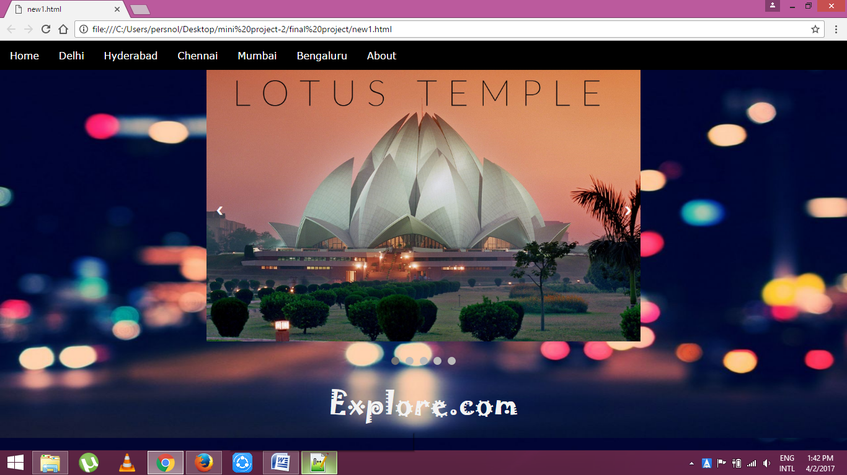

In the home page there are images of all the cities.

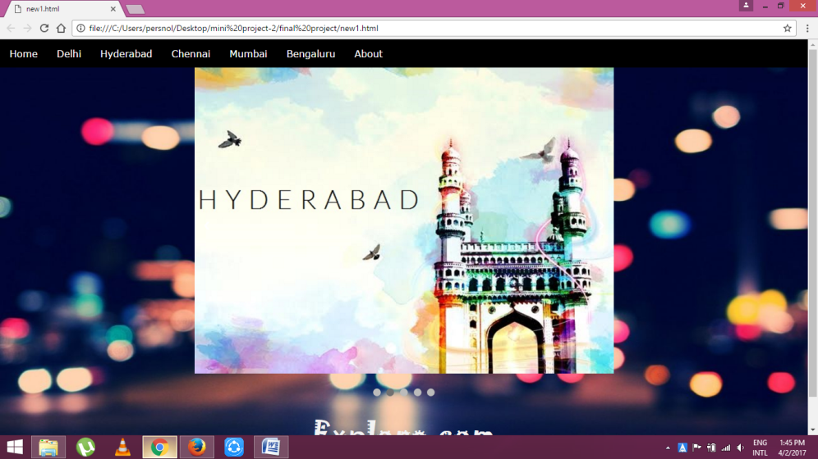*Hyderabad*

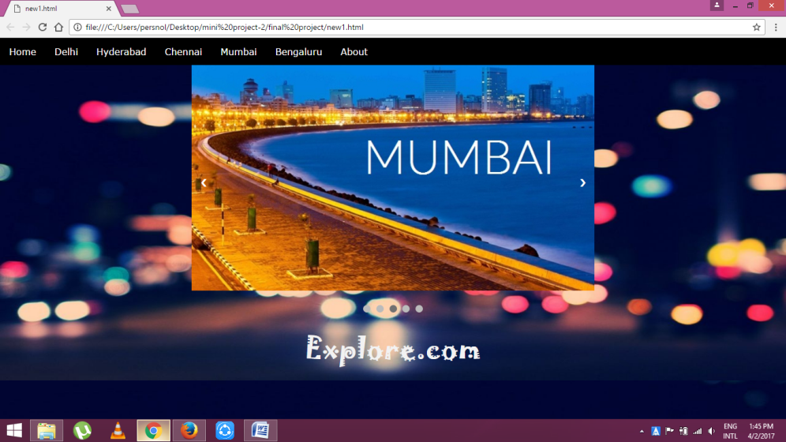 *Mumbai*

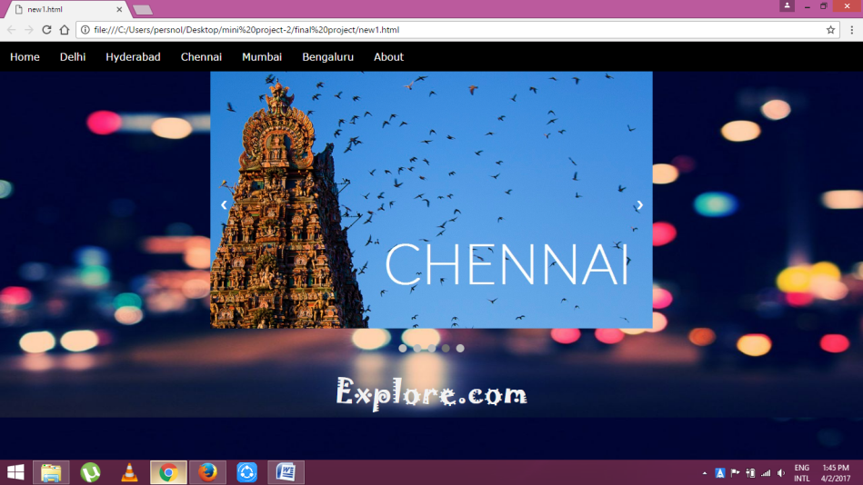 *Chennai*

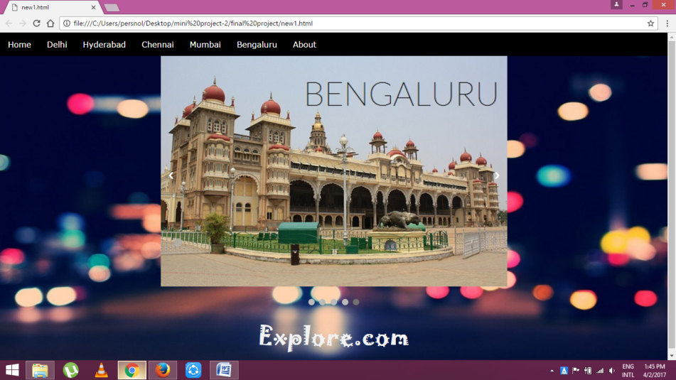 *Bangaluru*

**6.2 DELHI**

Delhi is one of the cities. Its main page is as follows

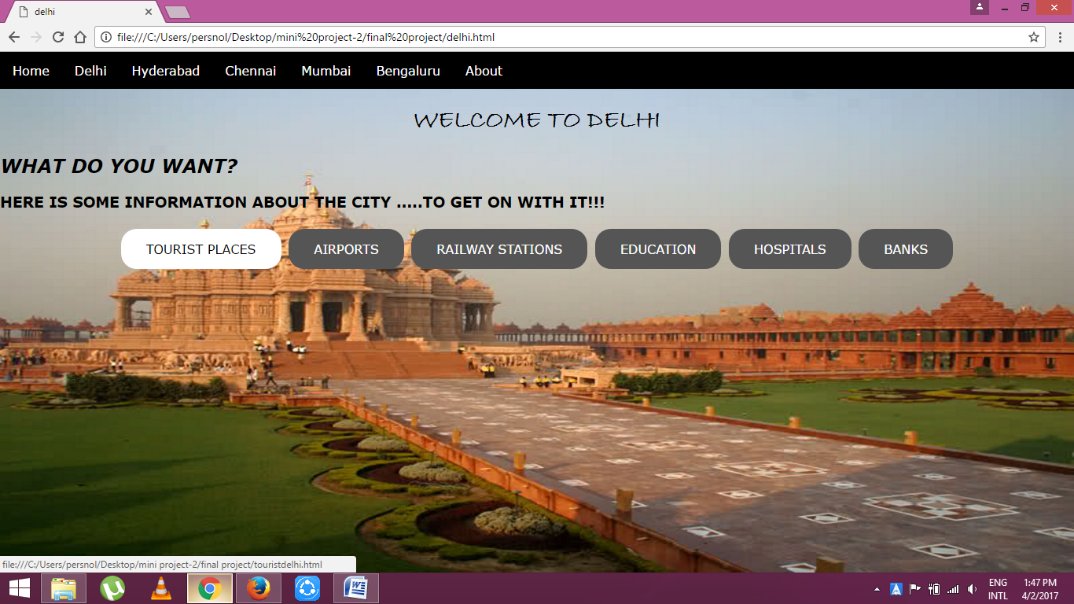

The black buttons in the above image are the buttons for all the categories. On hover they turns to white buttons. On single click on the buttons they display the page of the respective category.

The same is for all the cities in the website.

**6.2.1 Tourist places**

Under tourist places button all the places of that respective city all displayed as follows

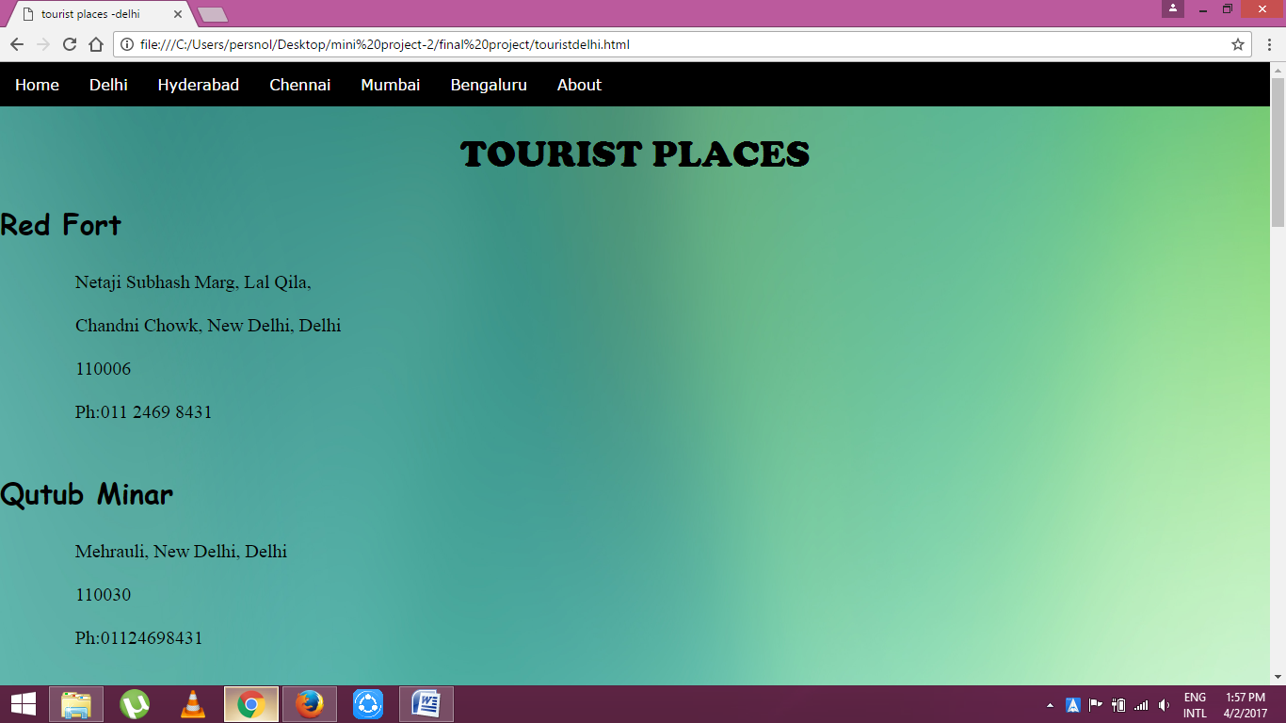

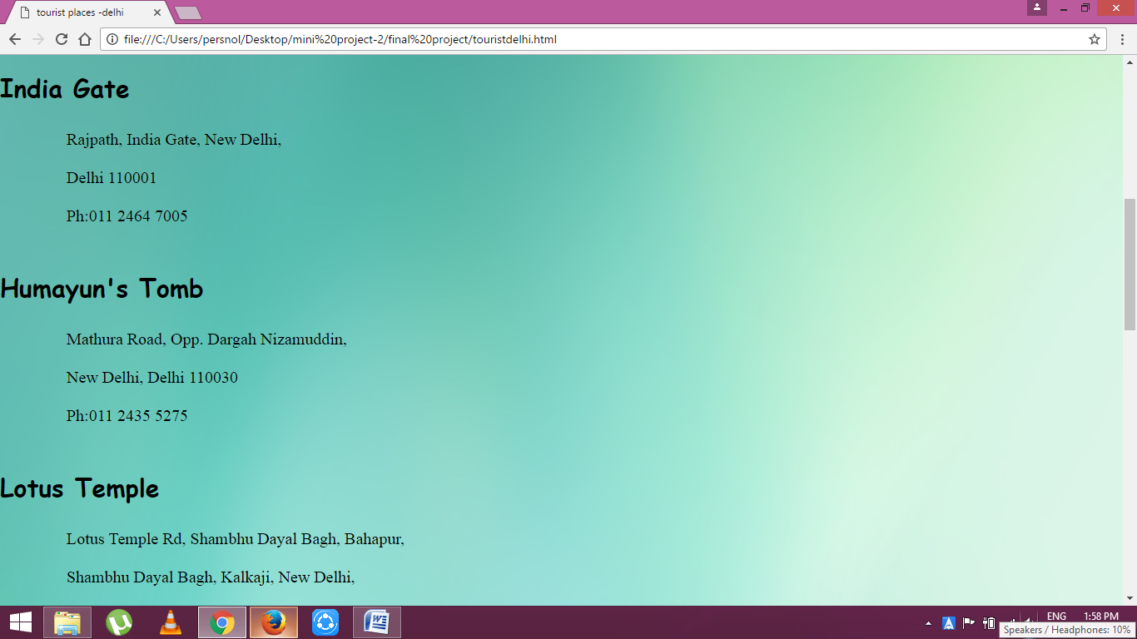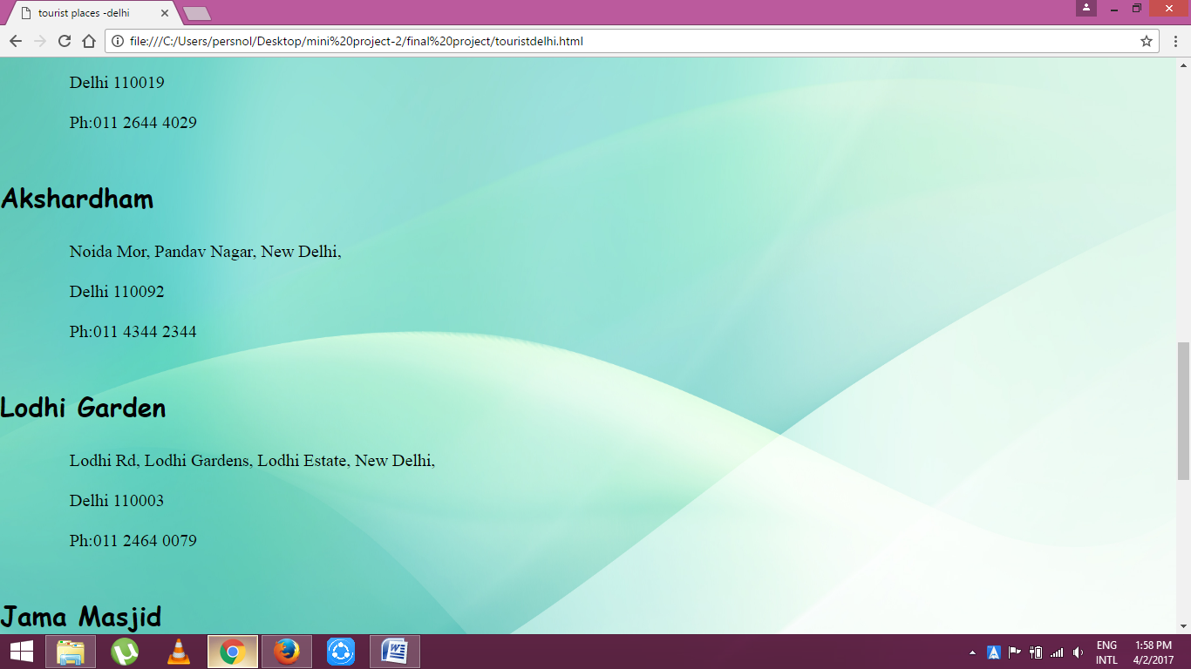

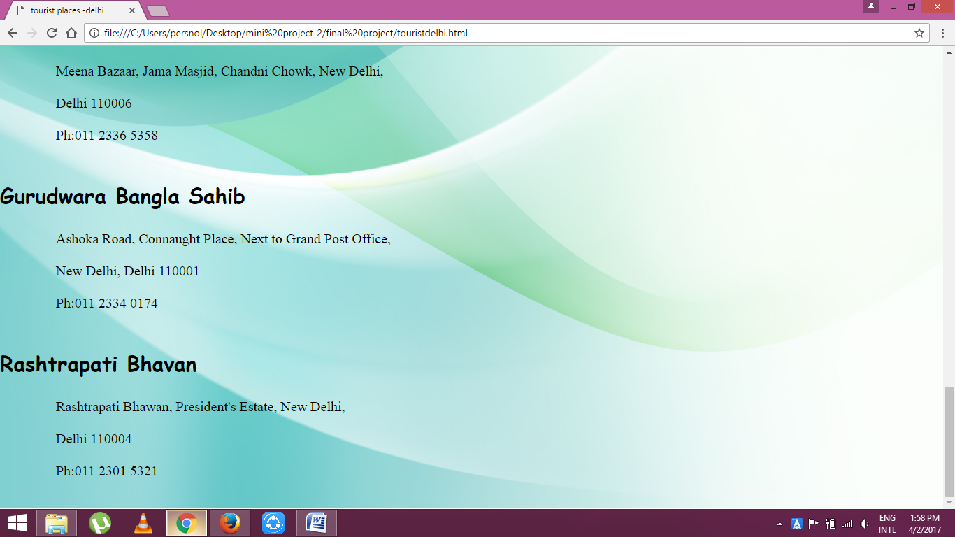

**6.2.2 Airports**

List of airports are as follows

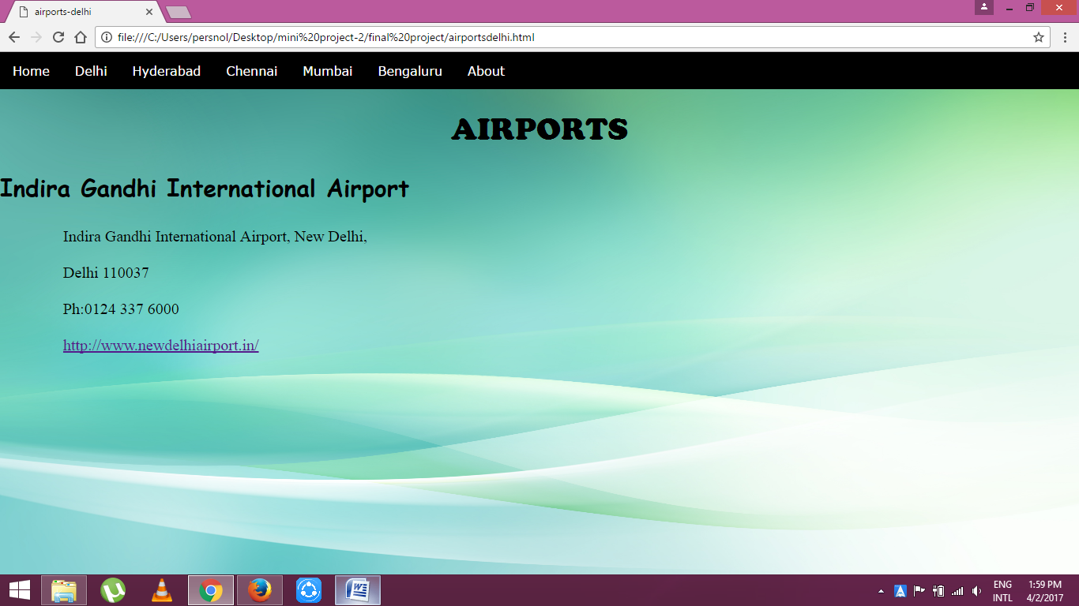

**6.2.2.1 Redirecting website**

A link is provided in the pages which directs to the official website of the corresponding details provided.

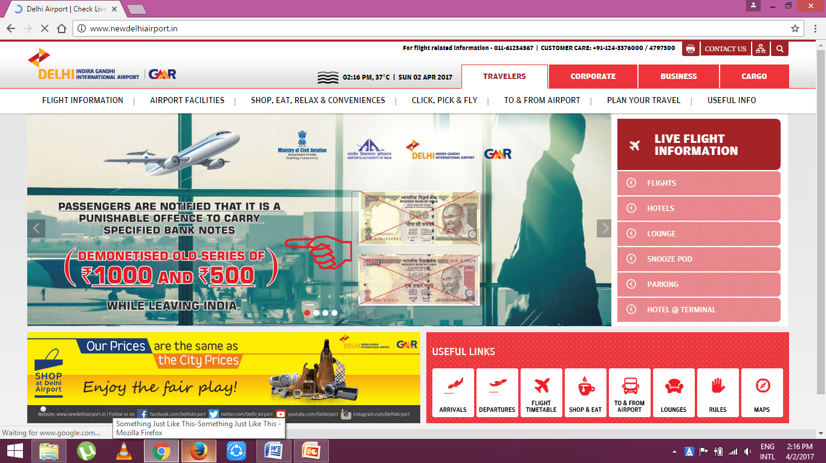

**6.2.3 Railway Stations**

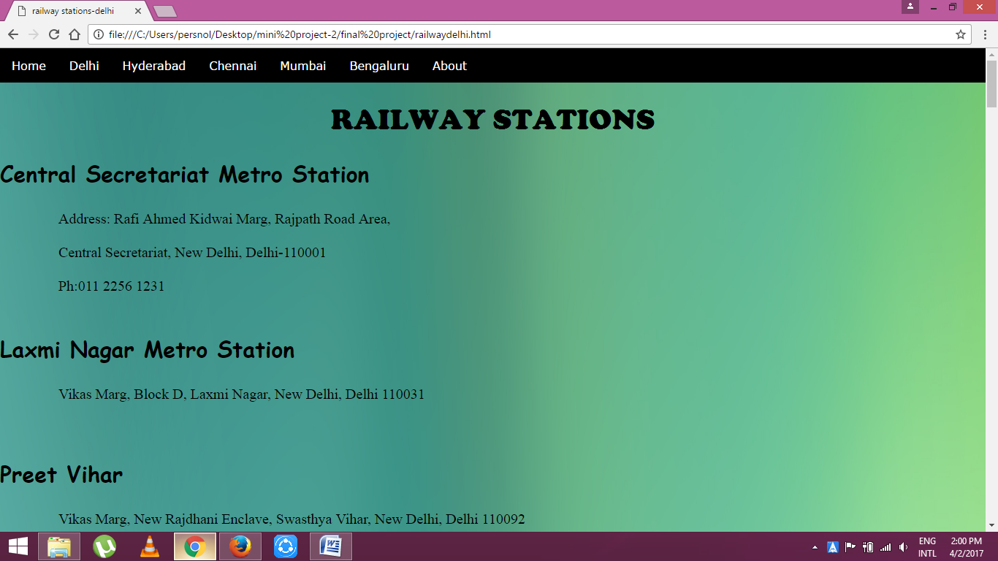

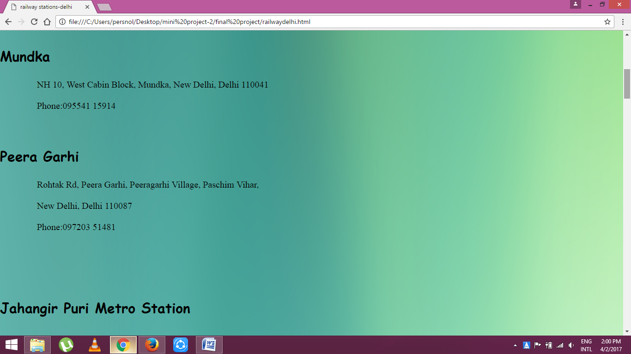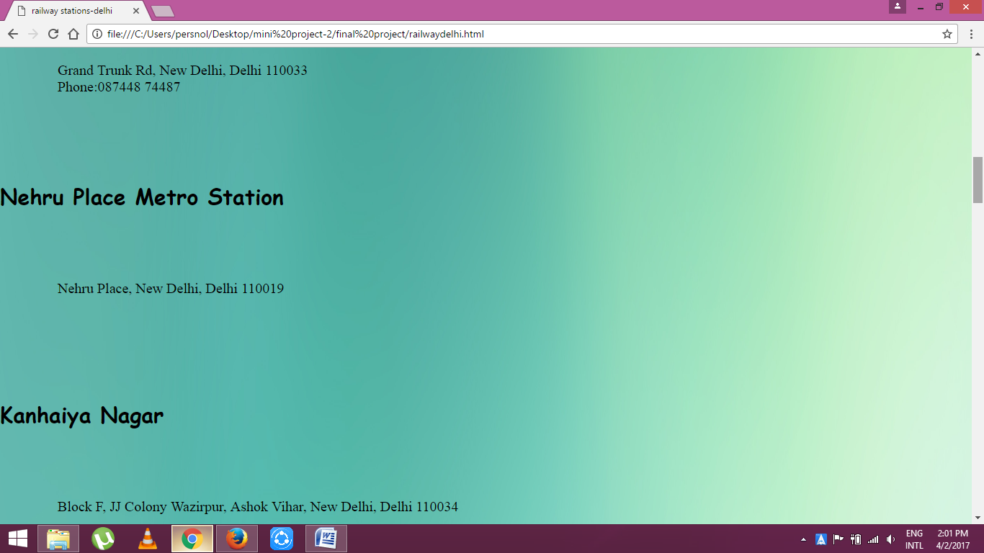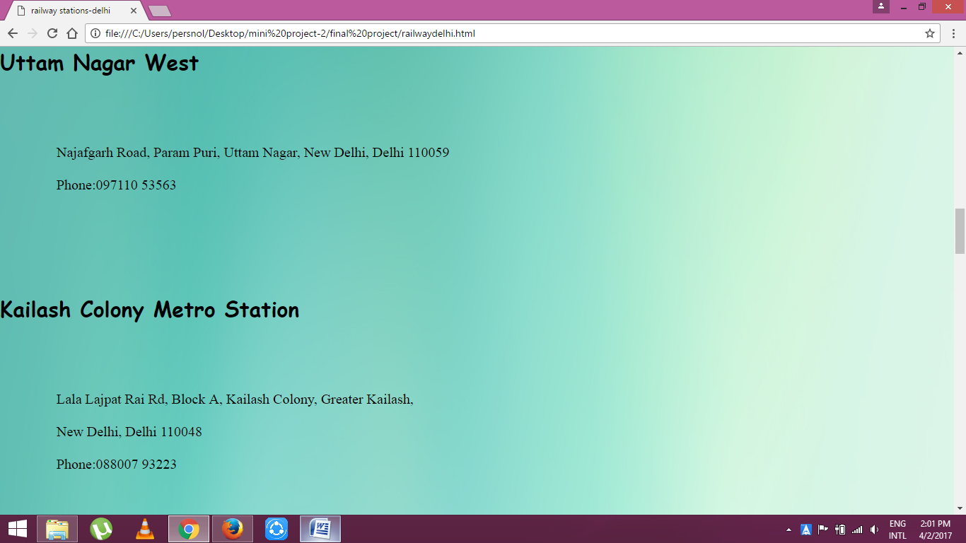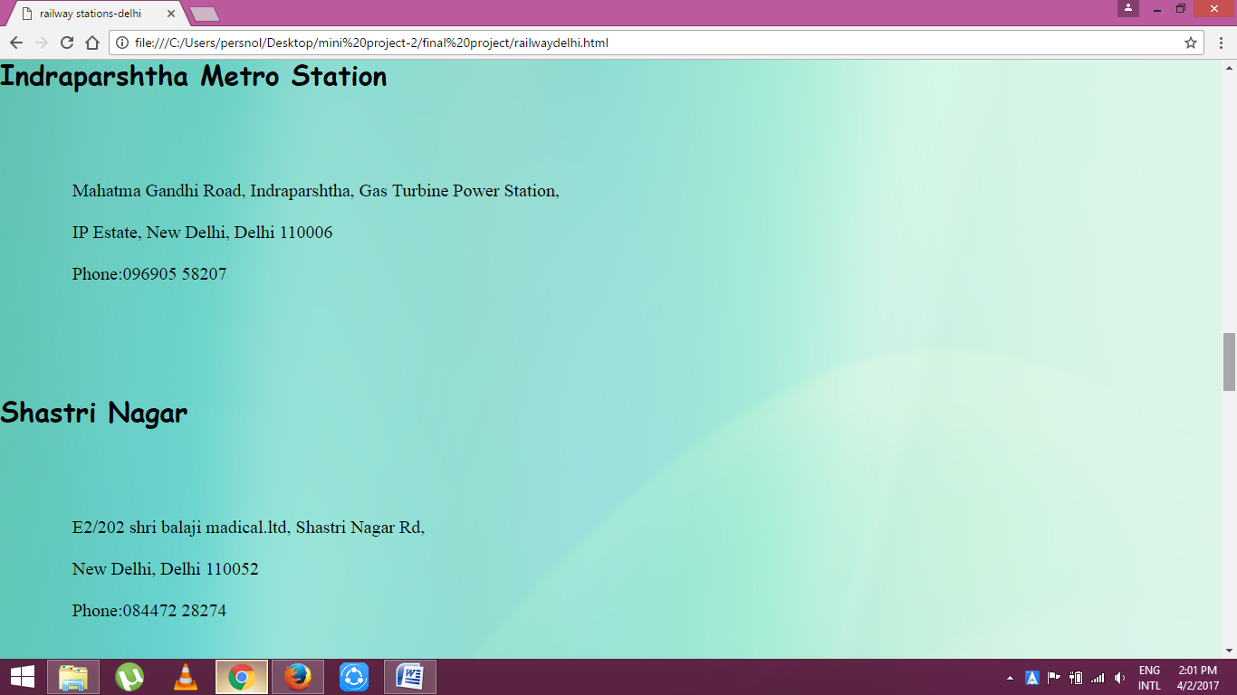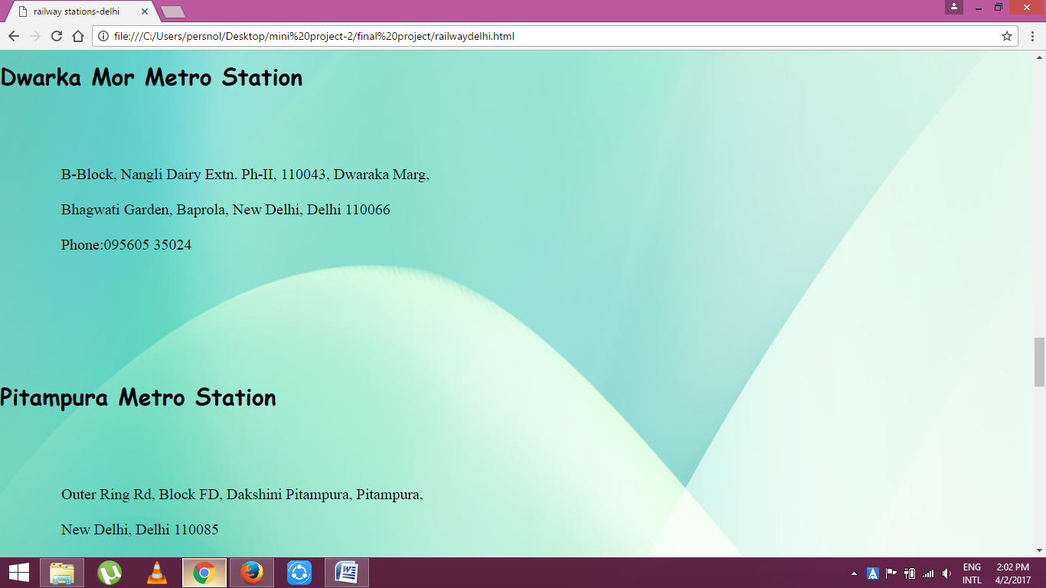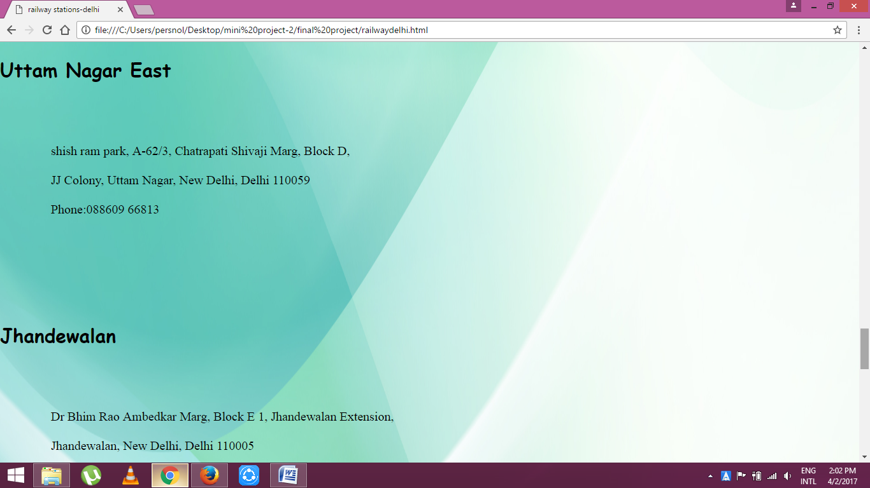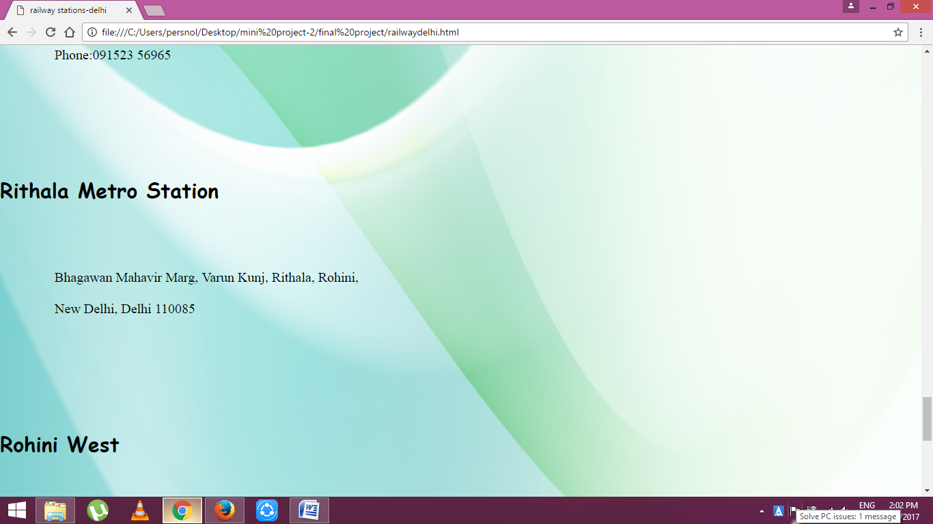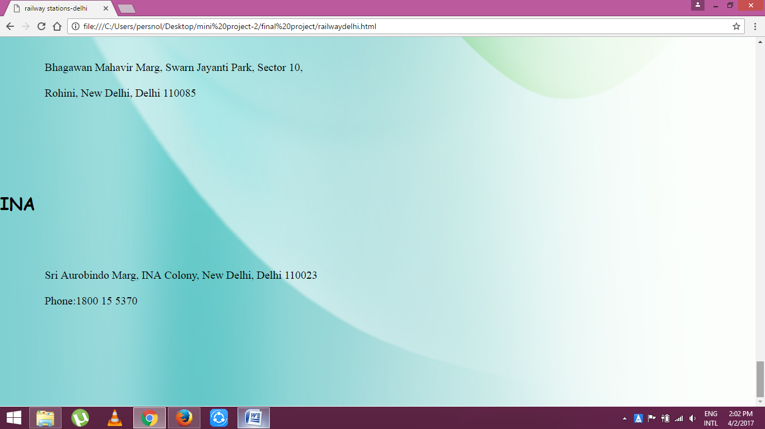

**6.2.4 Education**

Under education category universities, colleges and schools are included.

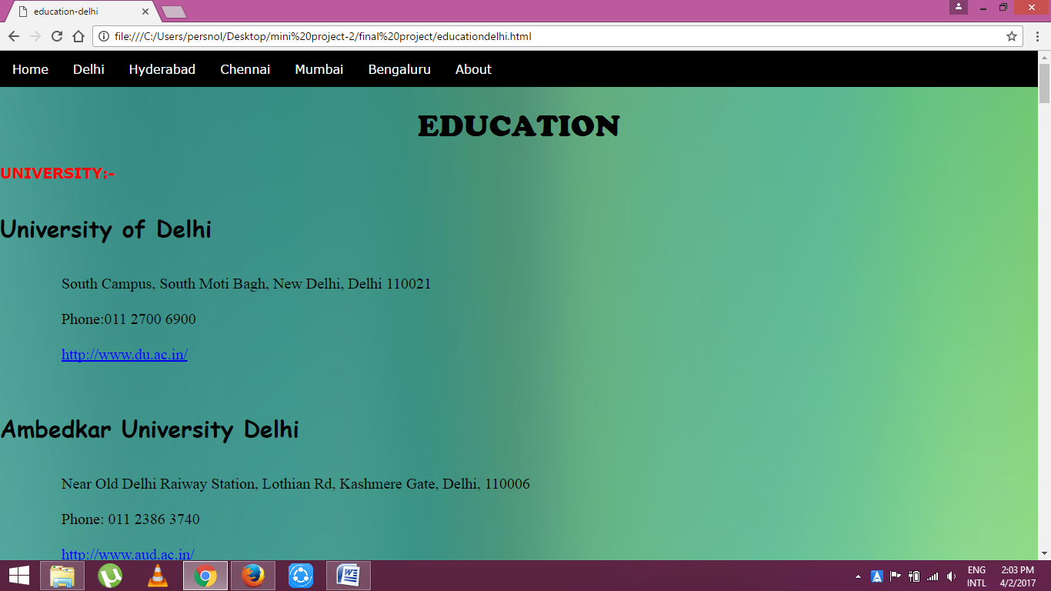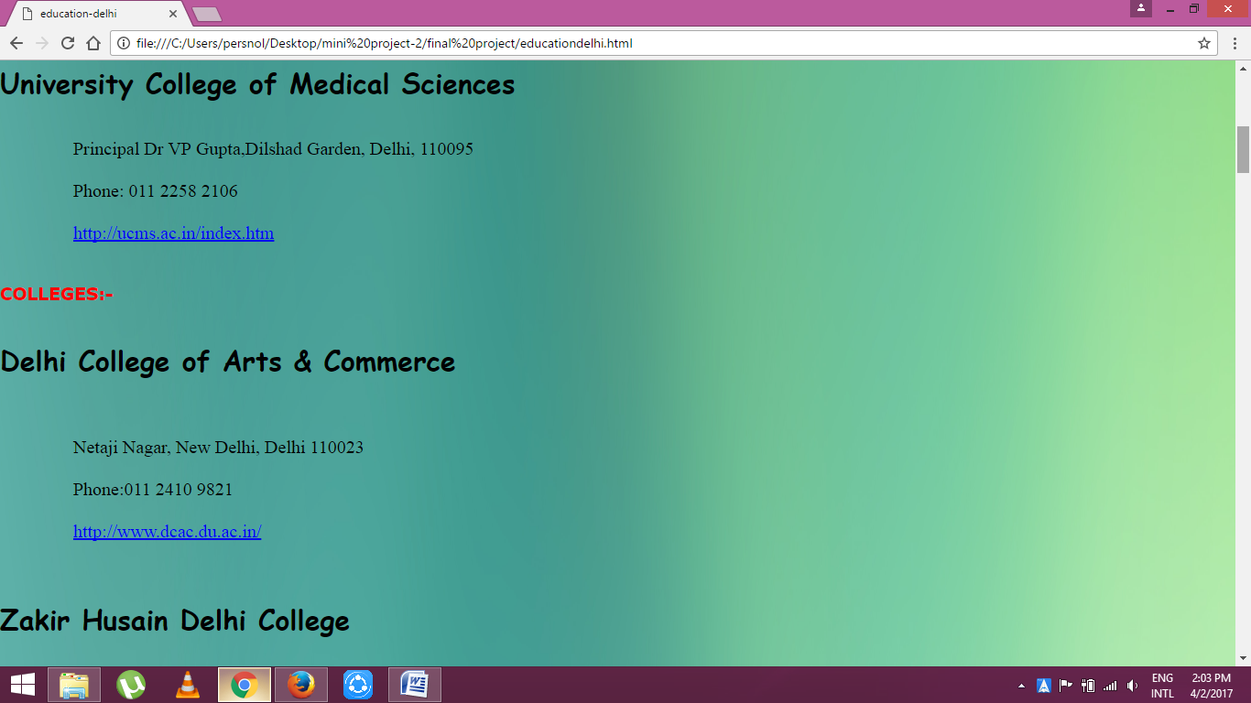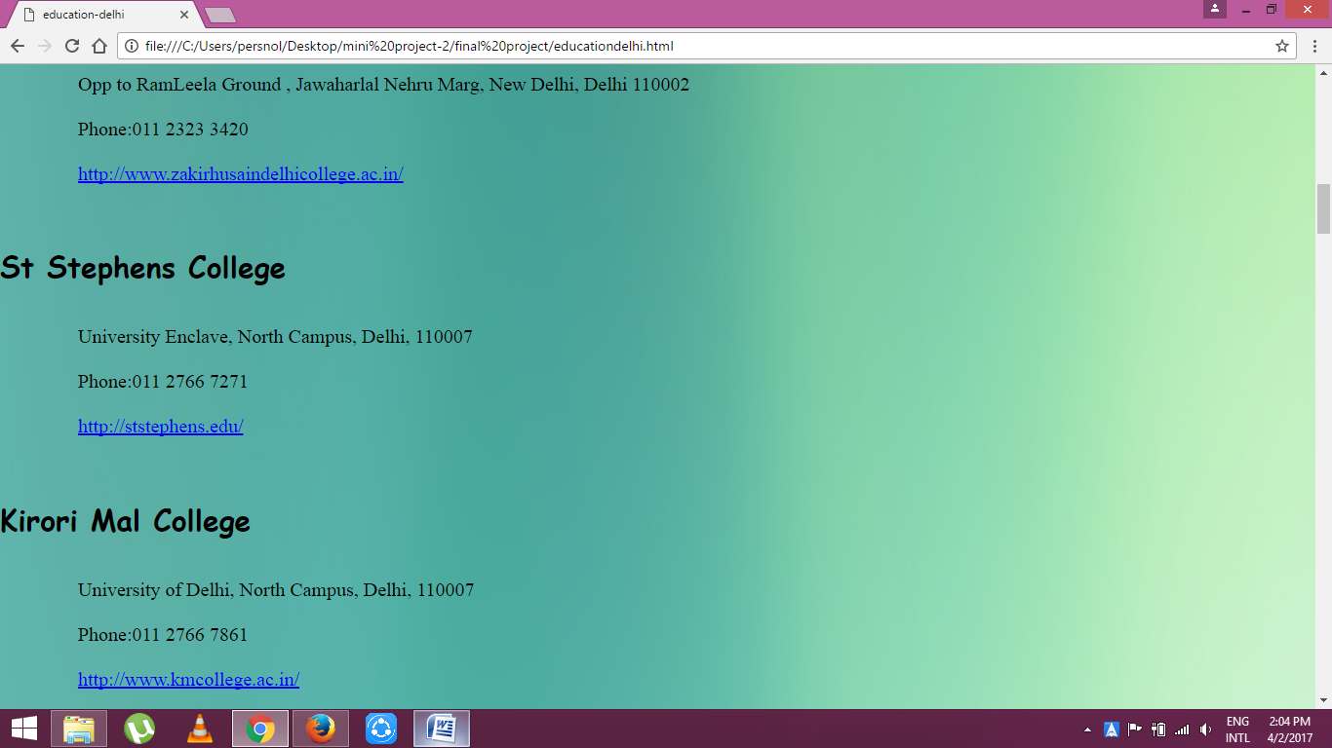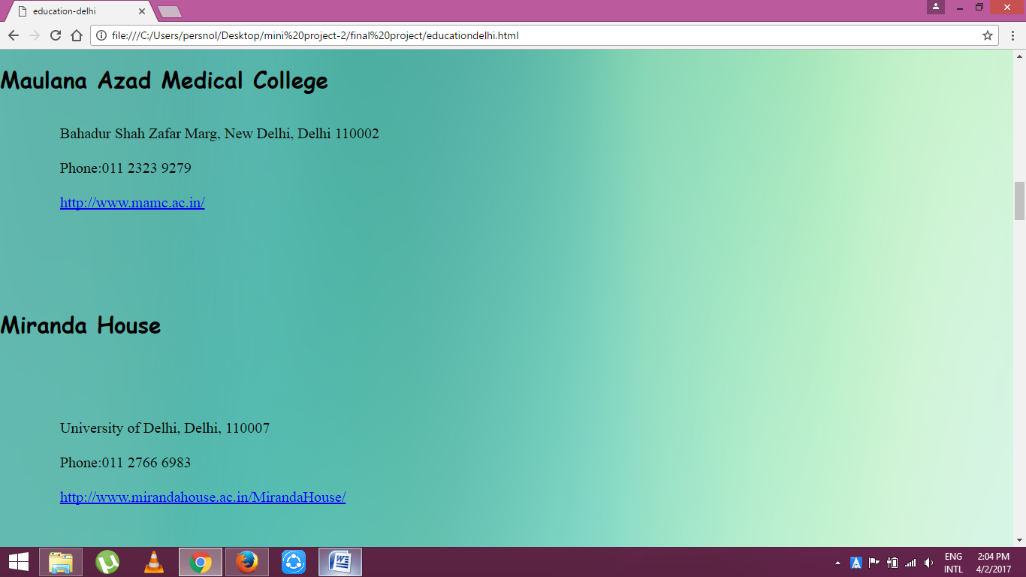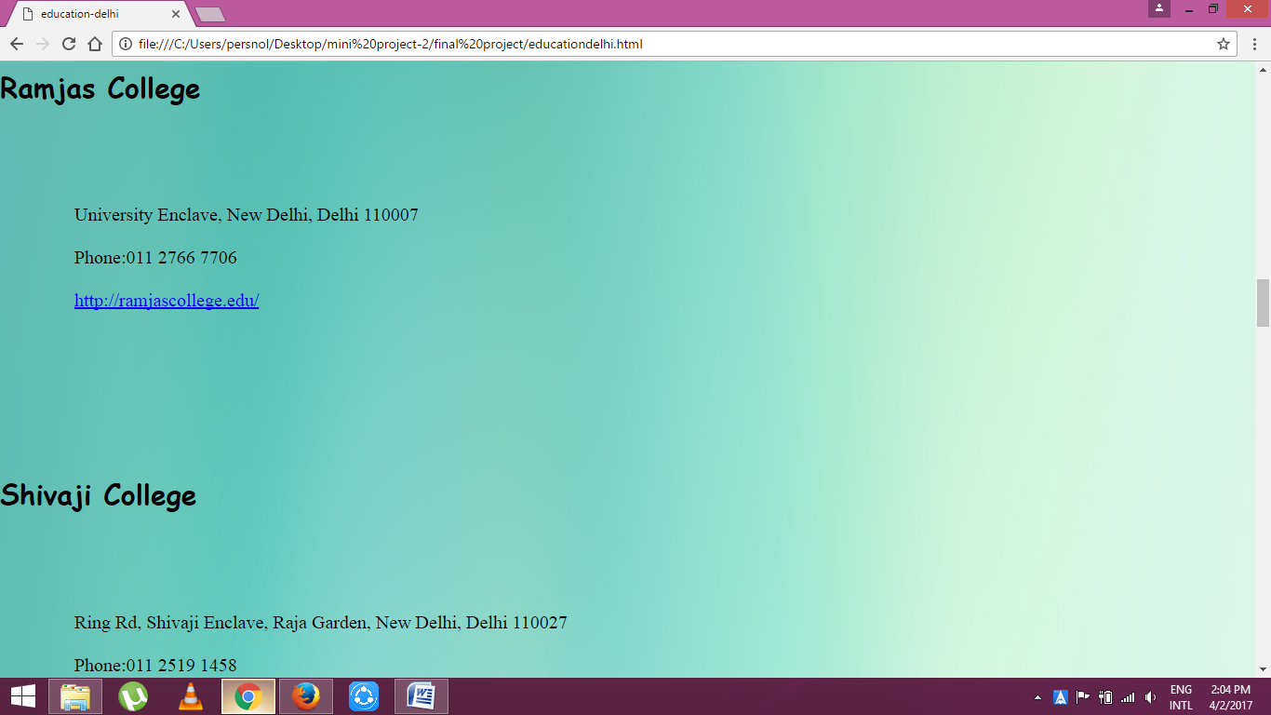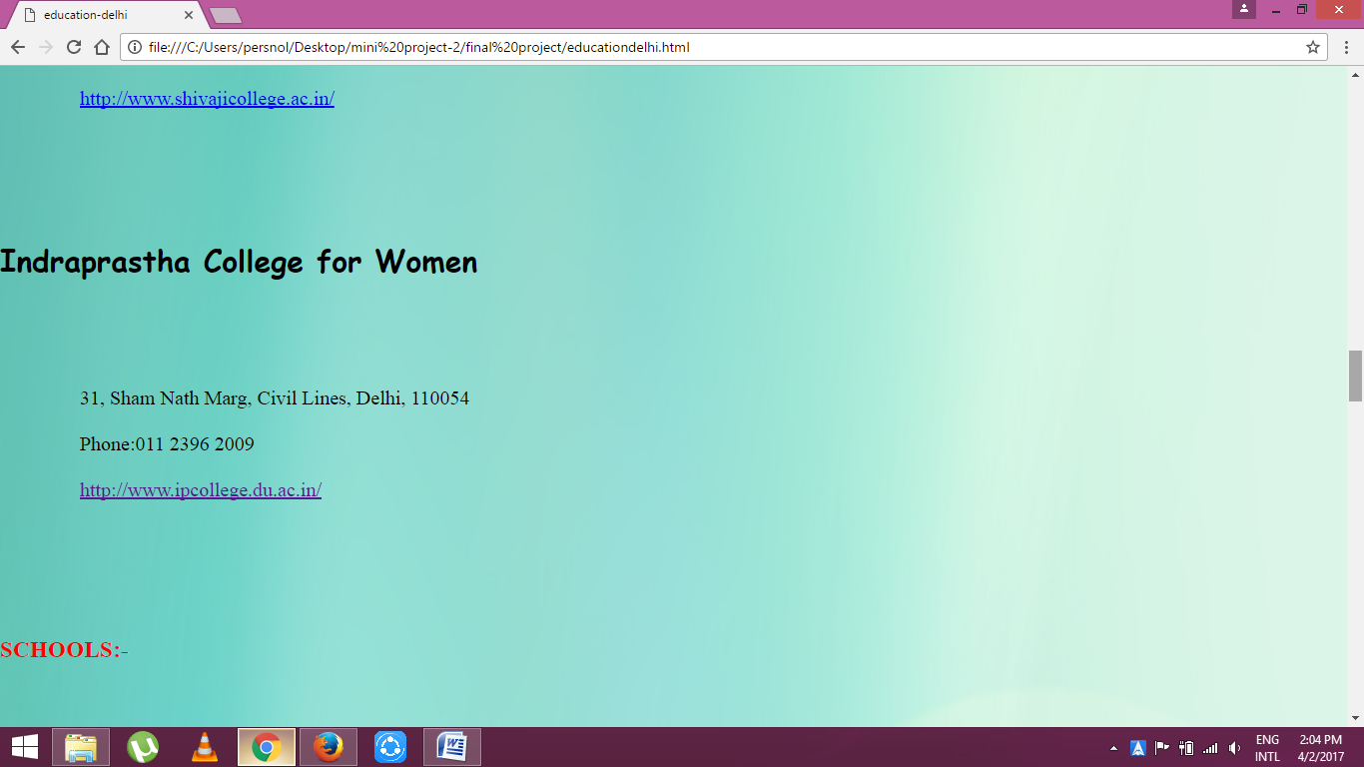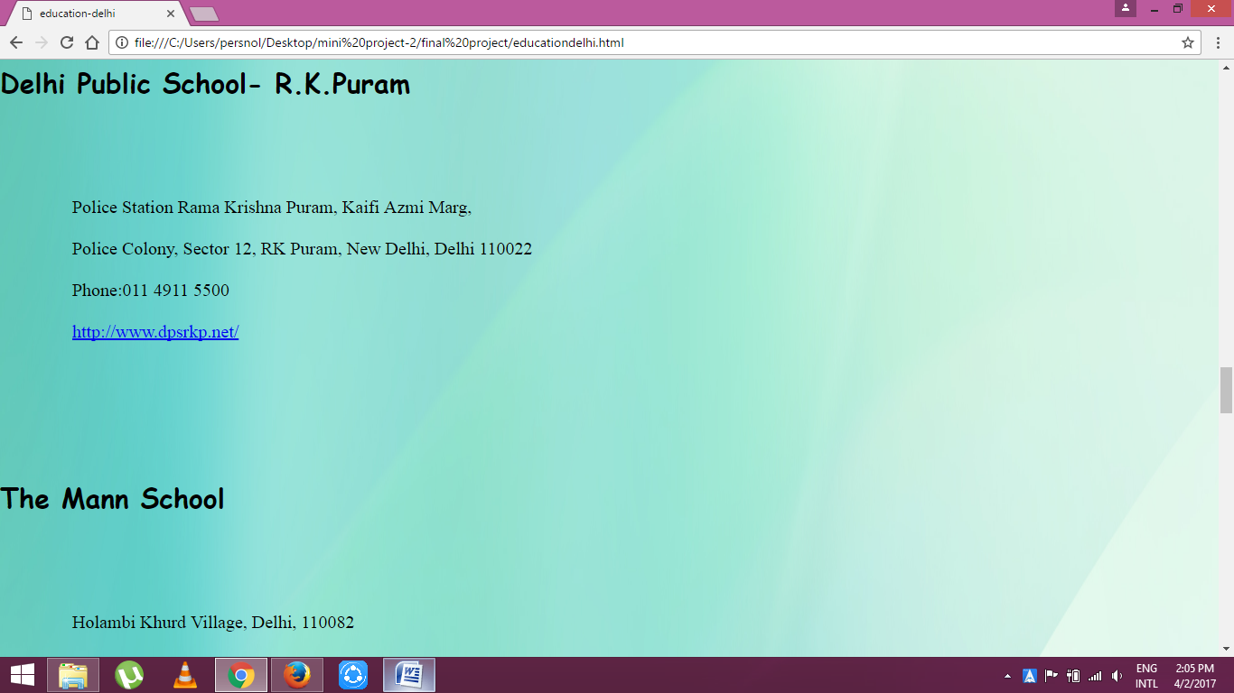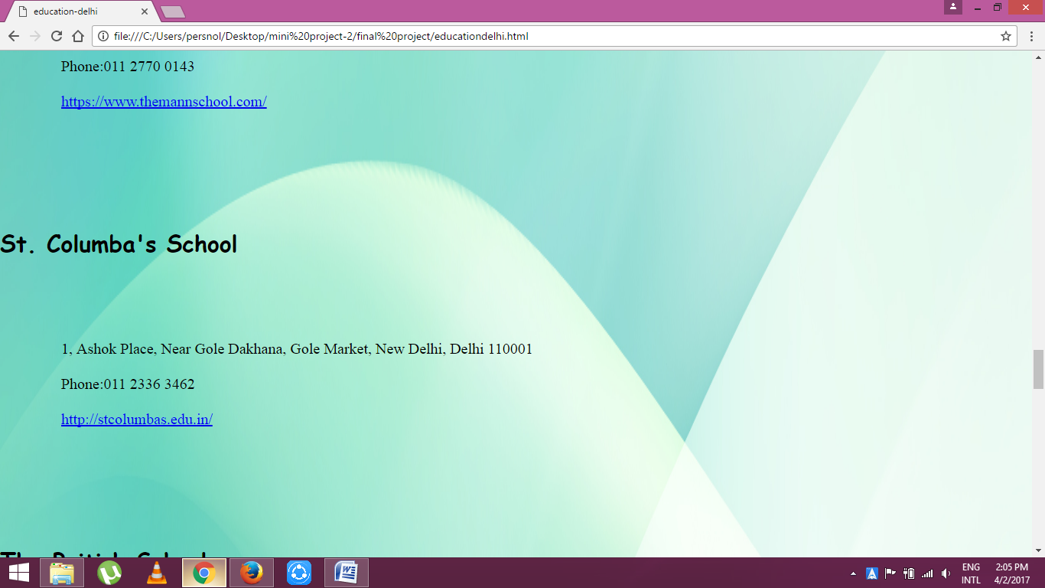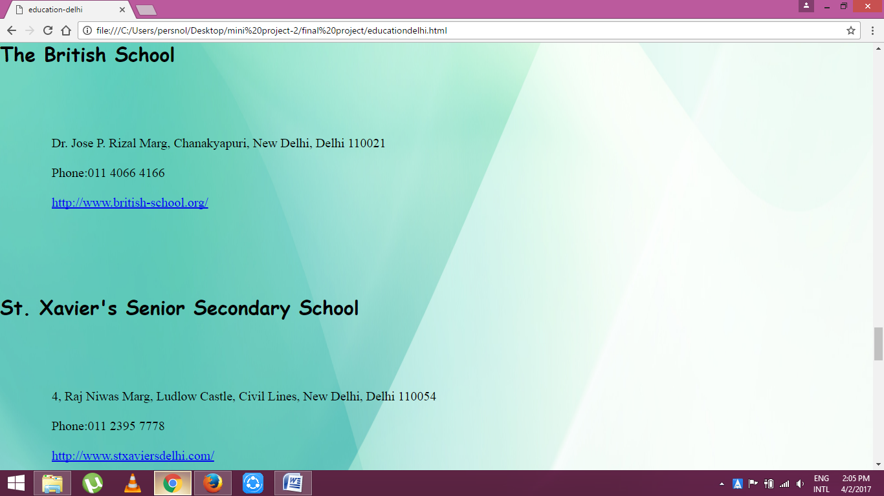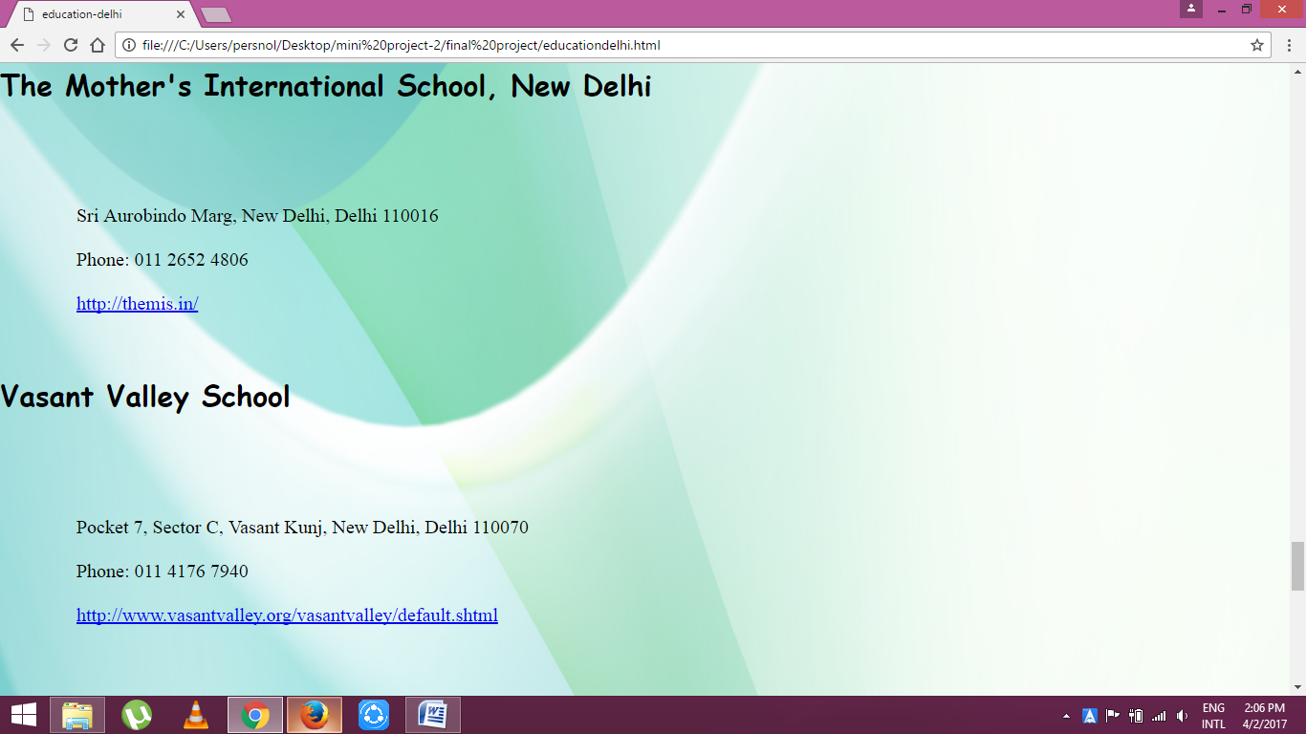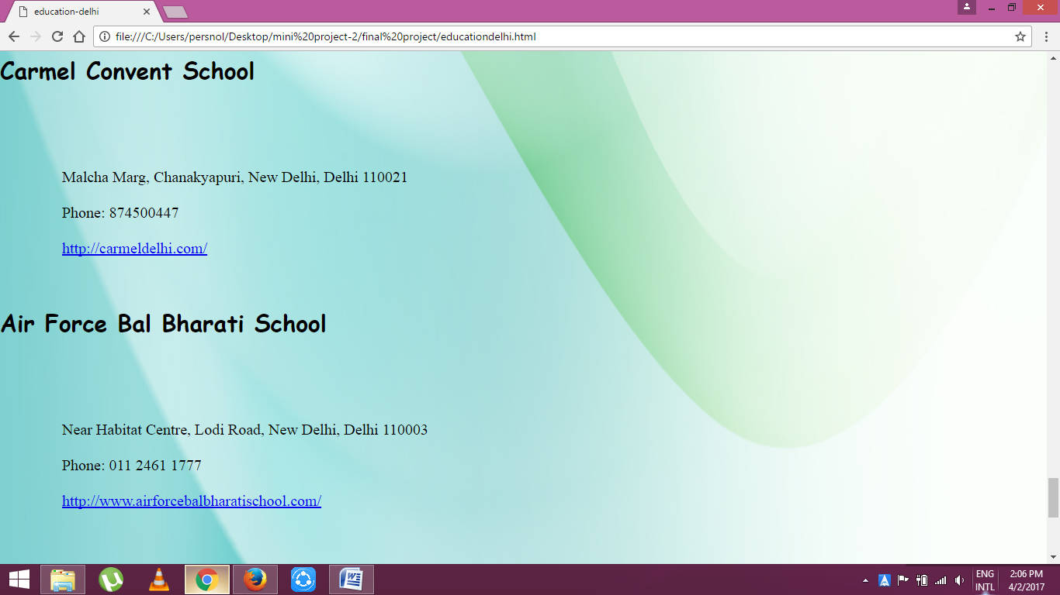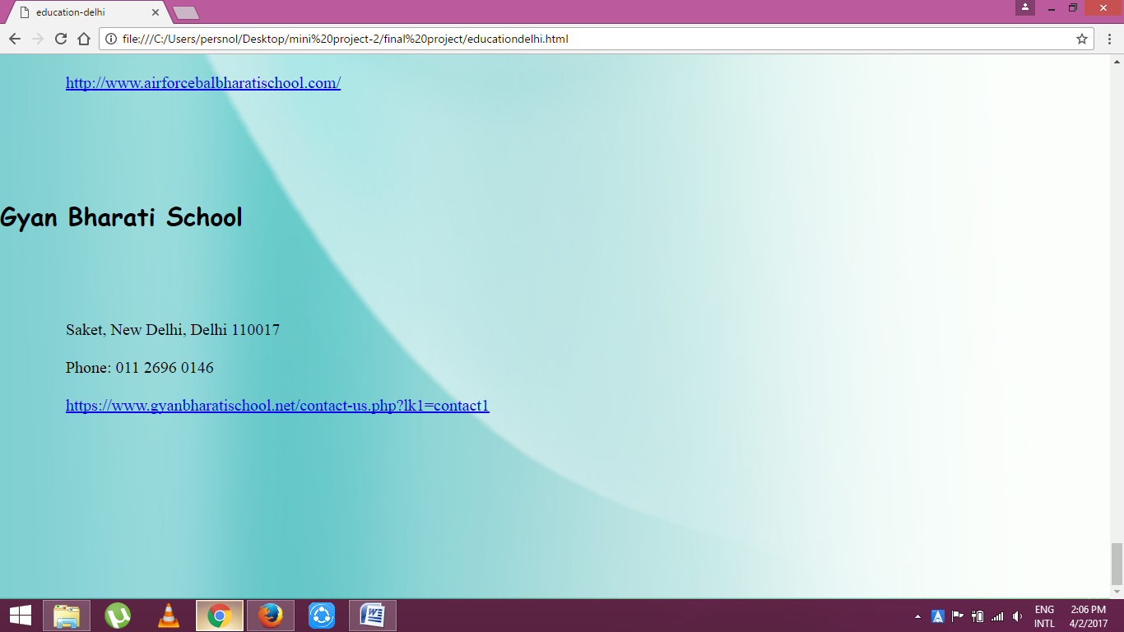

**6.2.5 Hospitals**

All the hospitals in the city are listed below.

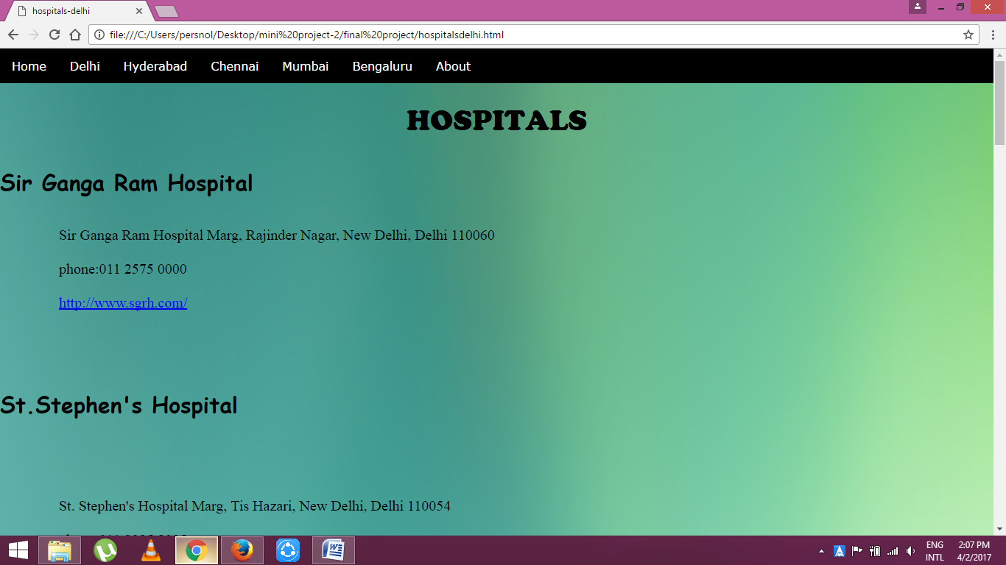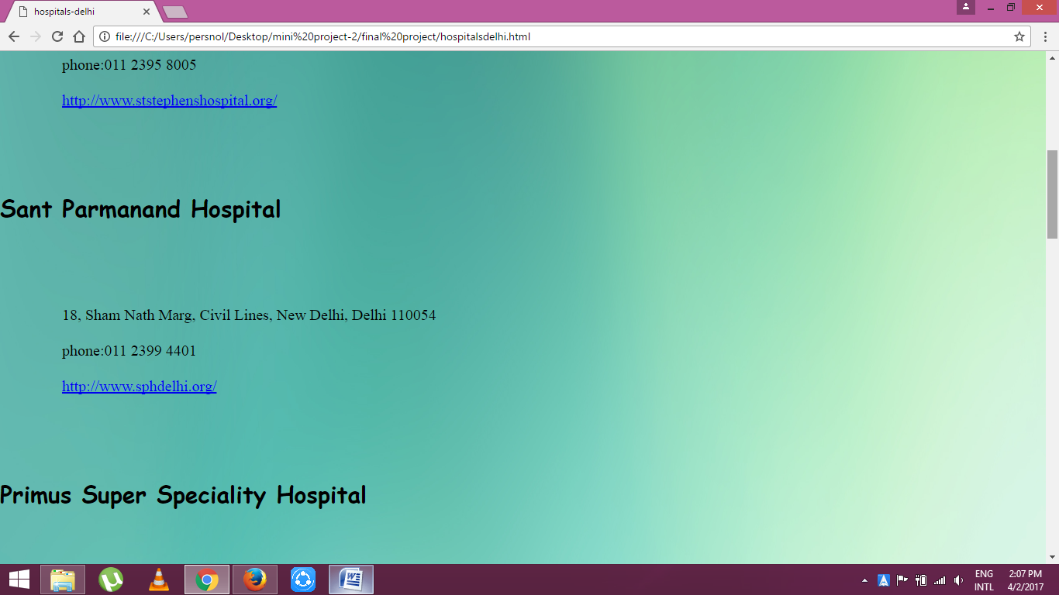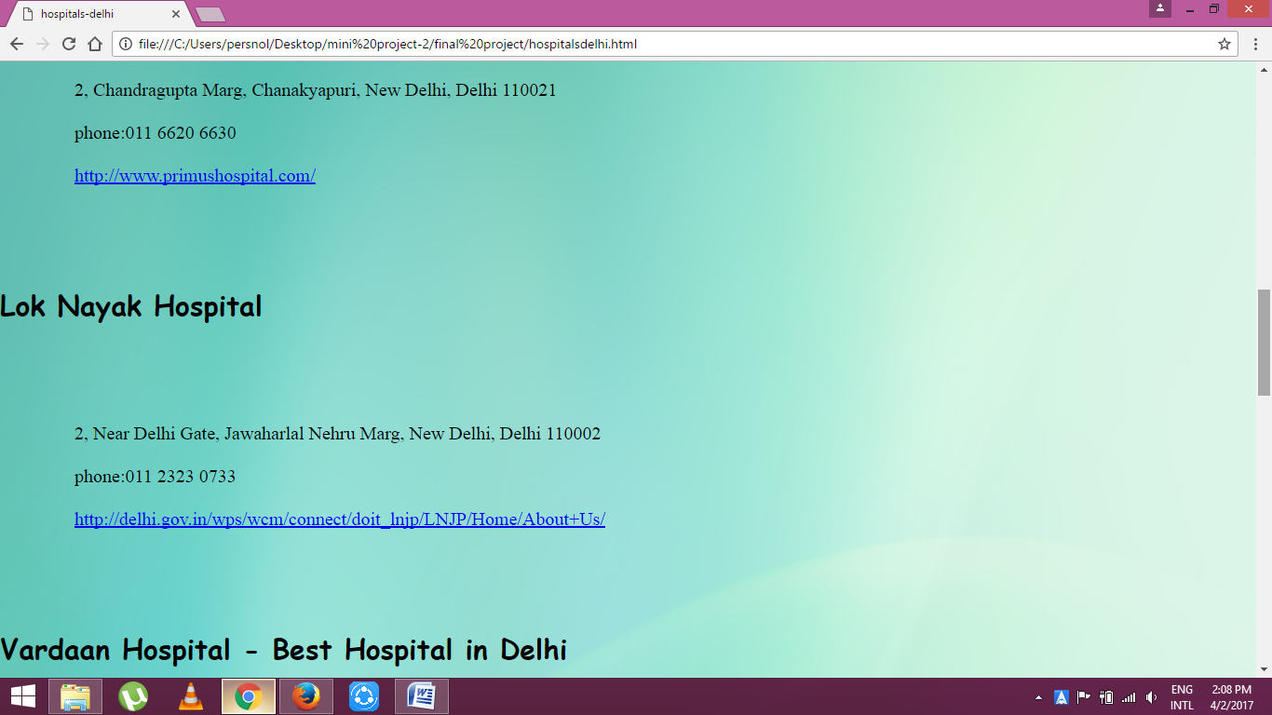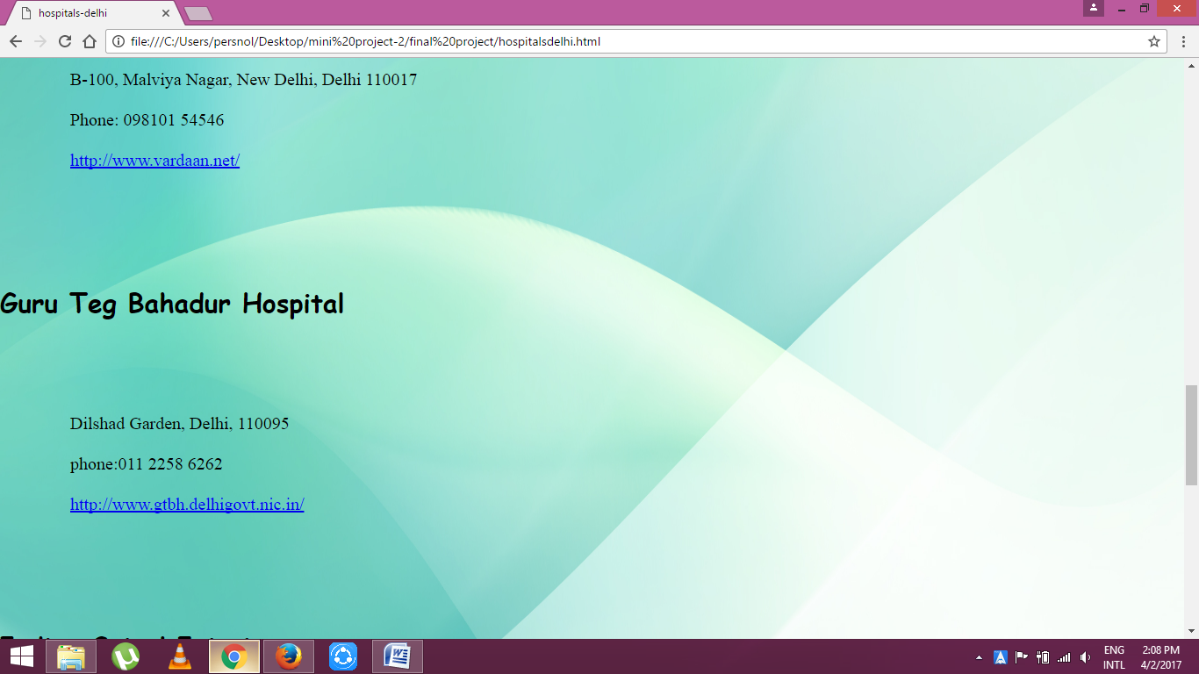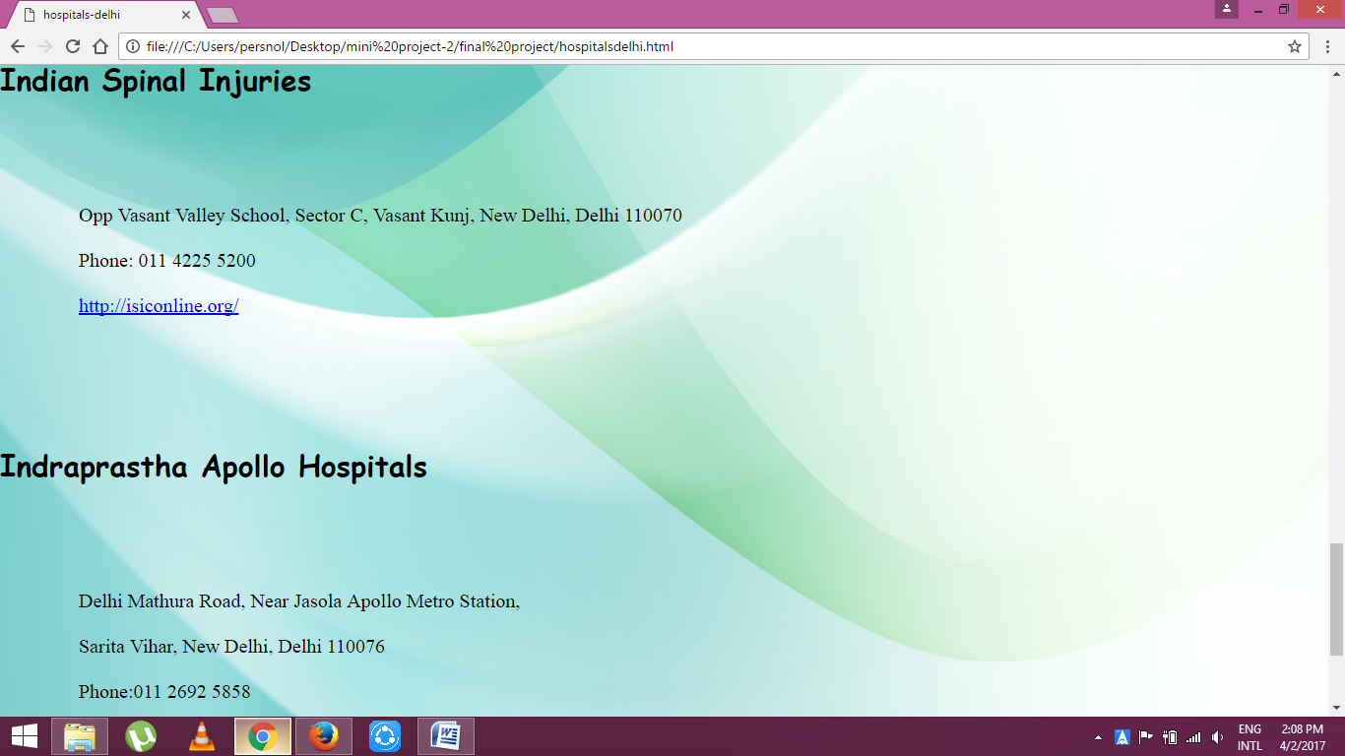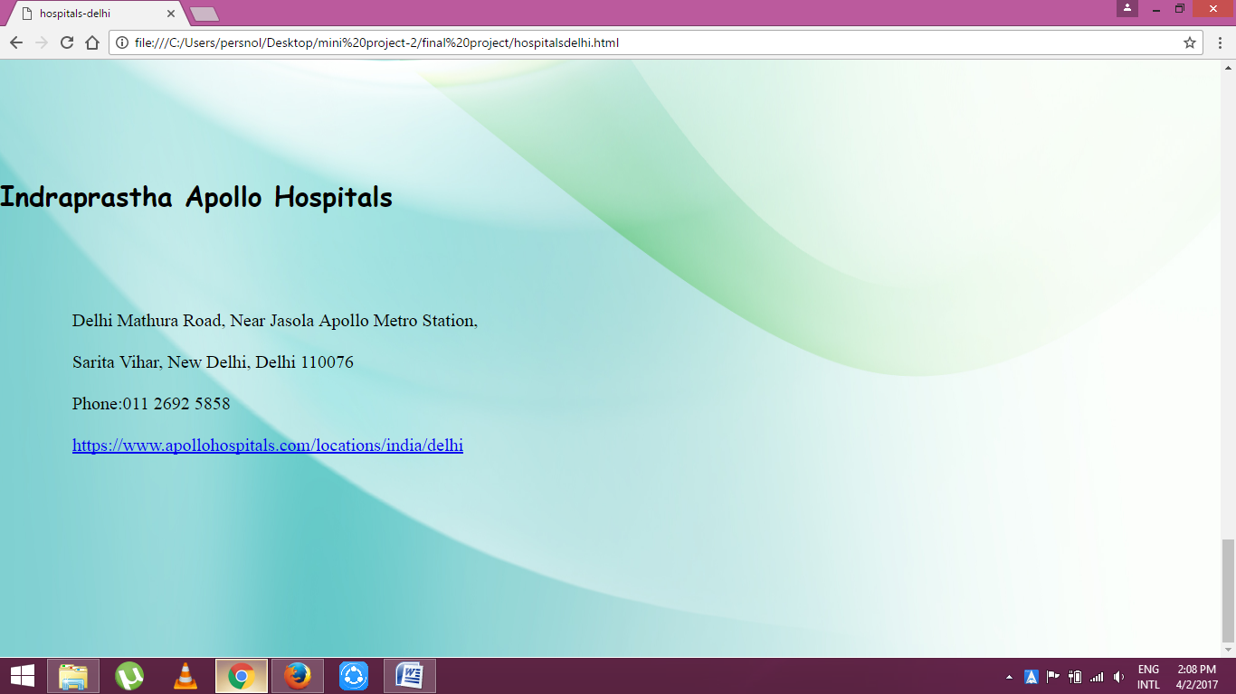

**6.2.6 Banks**

Bank list is displayed in this page.

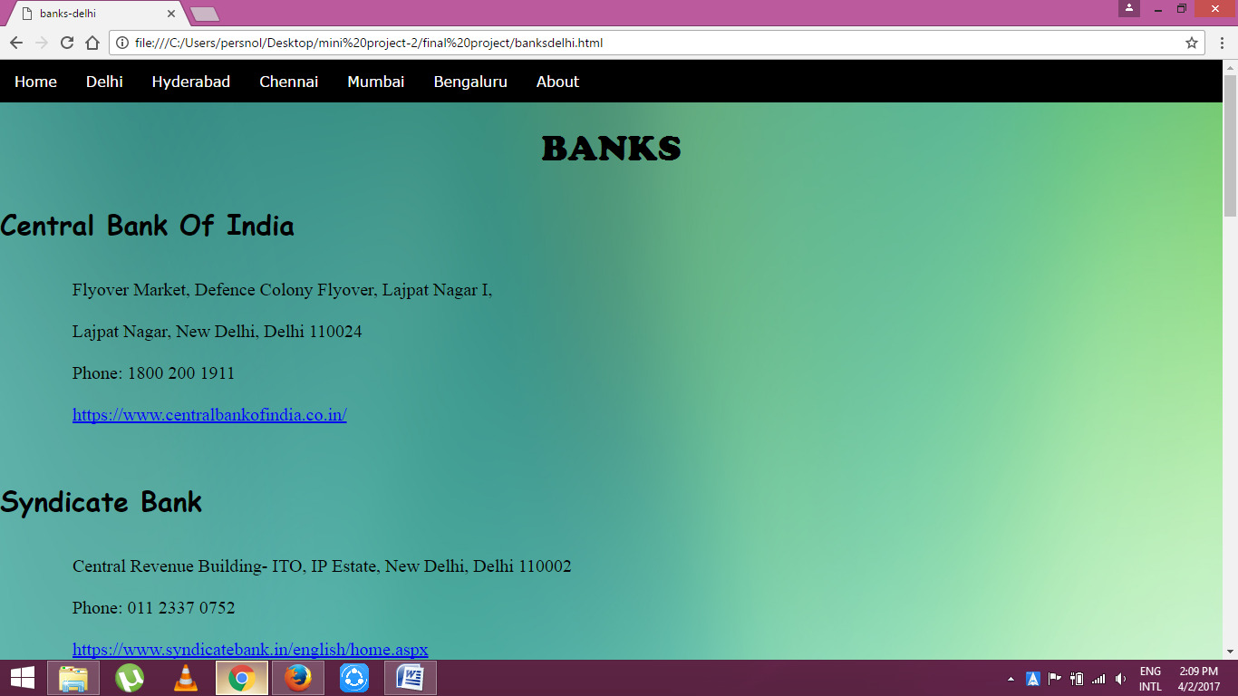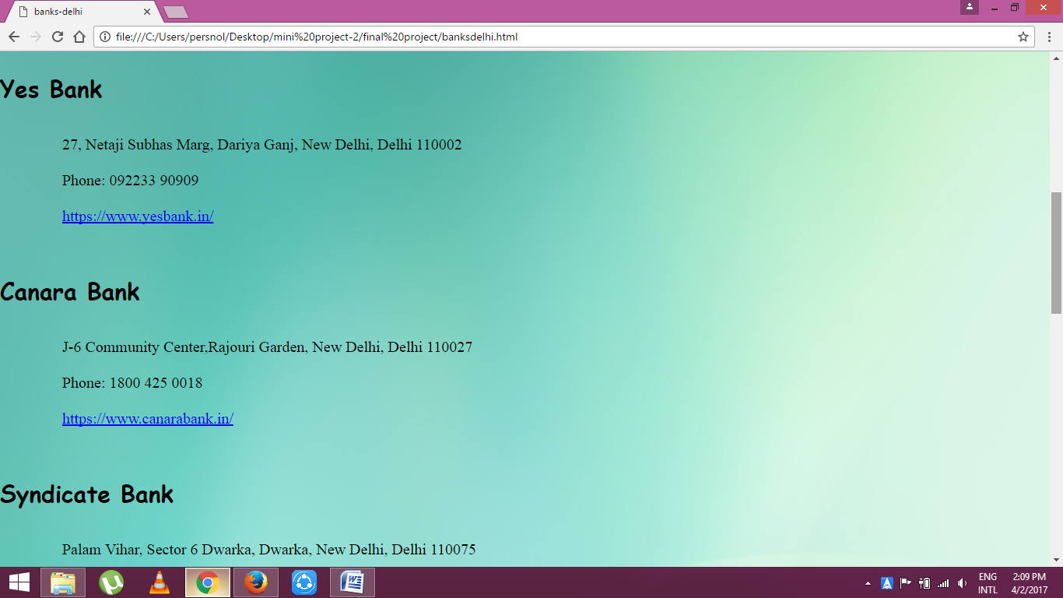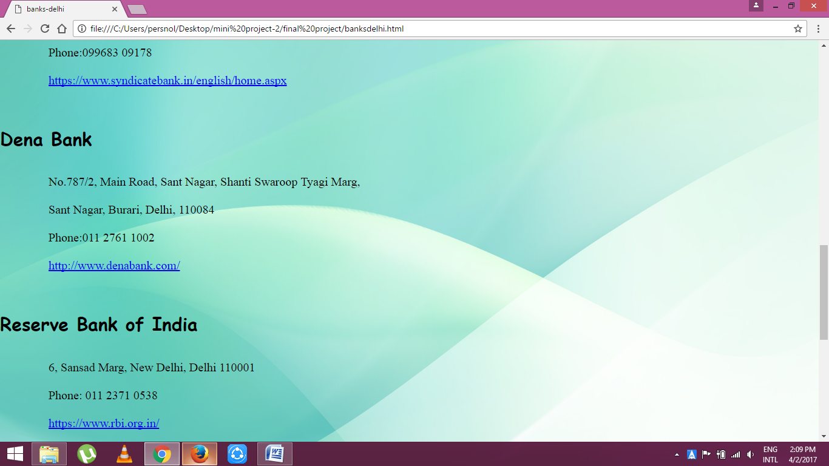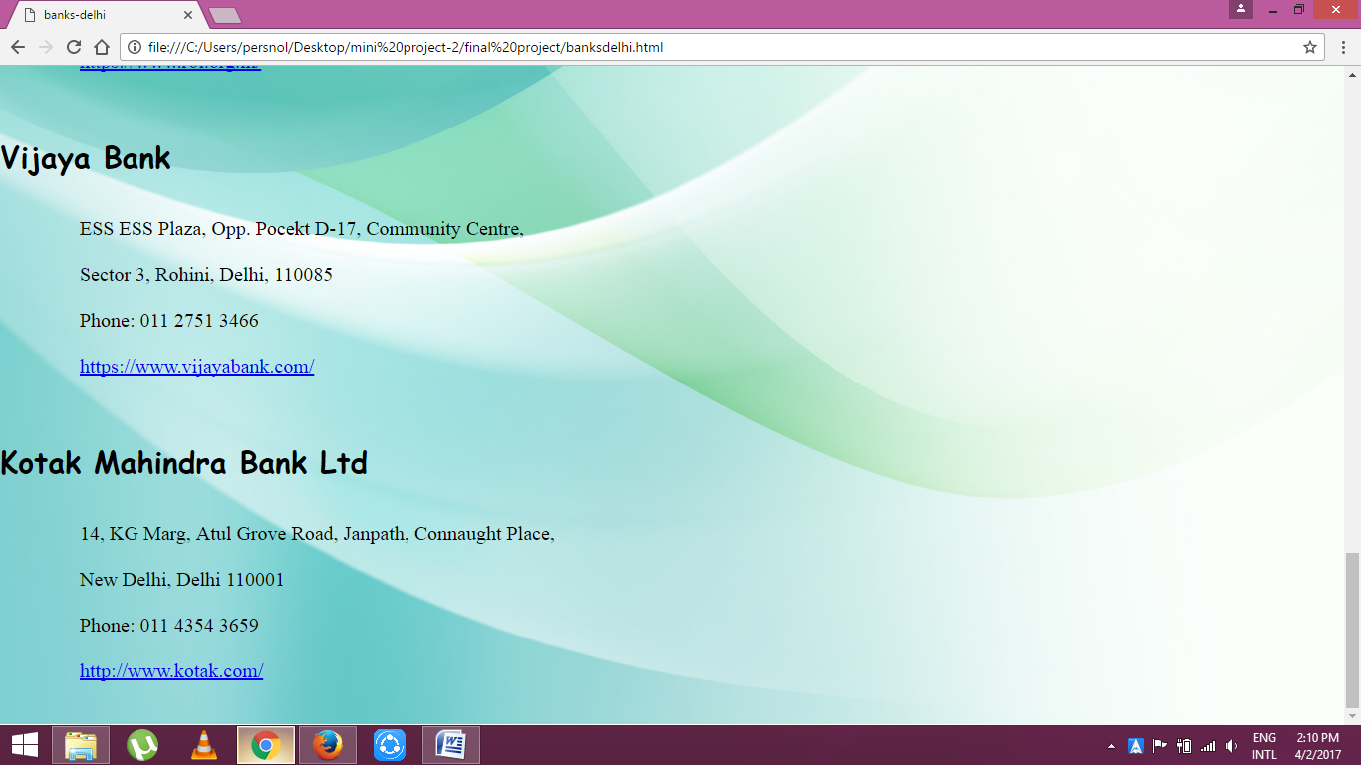

**6.3 Hyderabad**

The main page of Hyderabad is as follows.

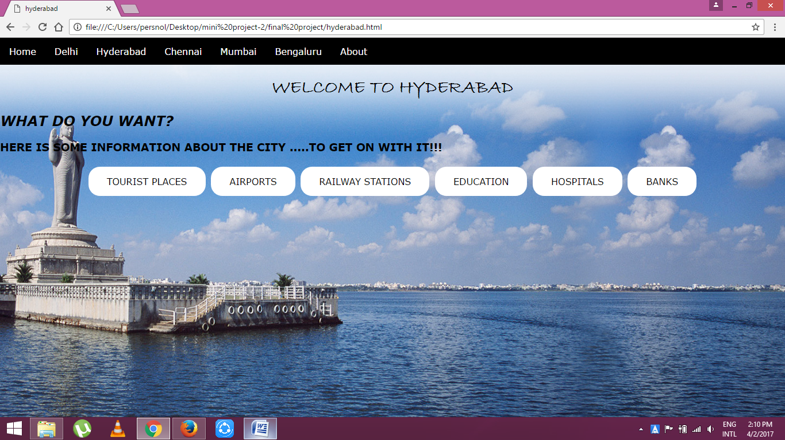

**6.4 Chennai**

The main page of Chennai in displayed as follows.

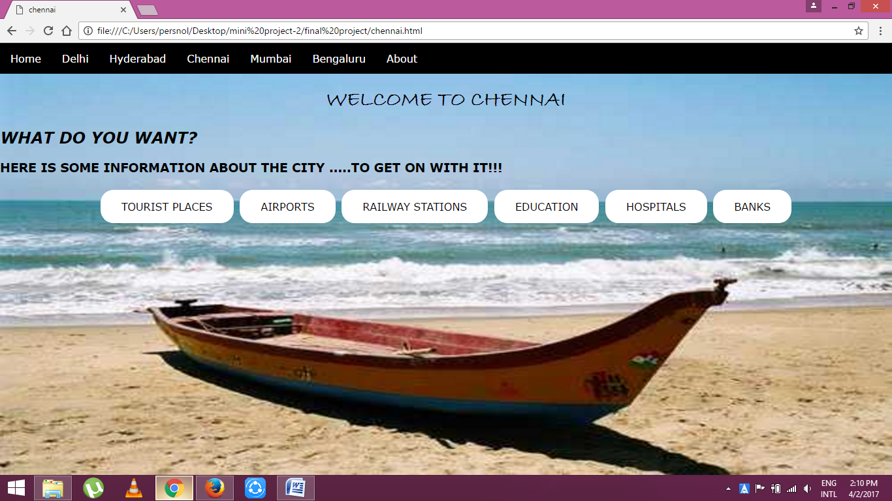

**6.5 Mumbai**

The main page of Mumbai is as follows.

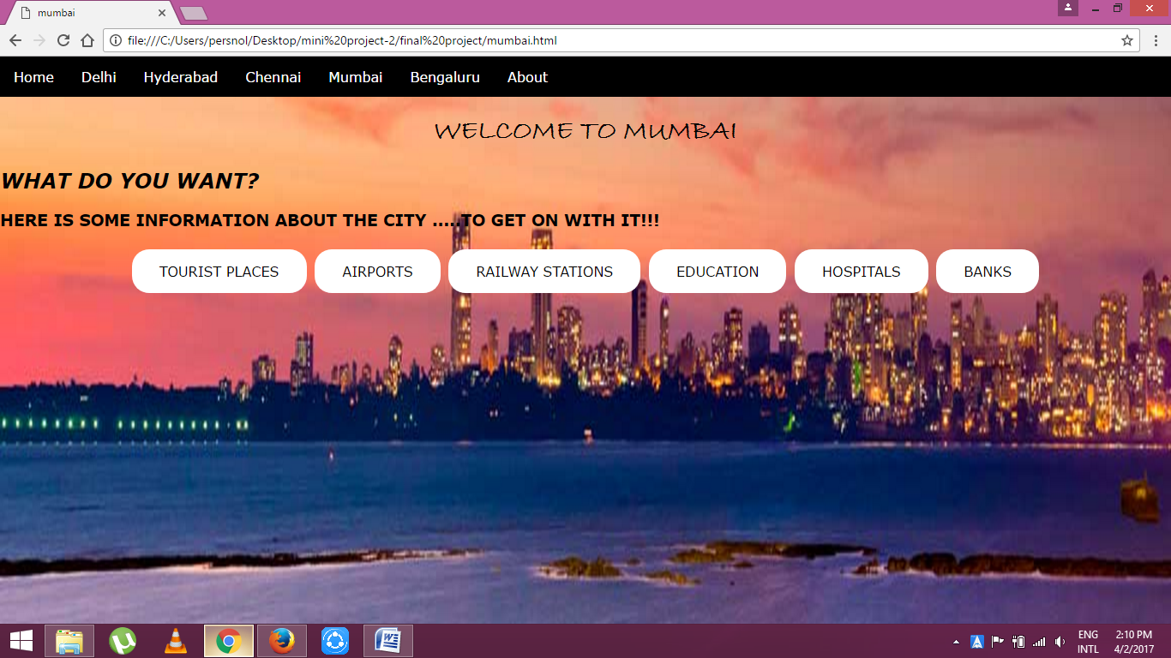

**6.6 Bengaluru**

The main page of bengaluru is as follows.

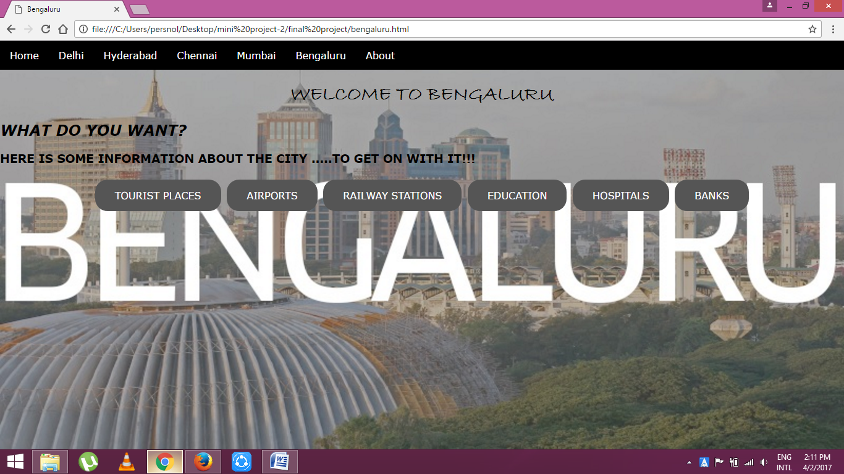

**6.7 About**

The summary about the website is displayed in this page.

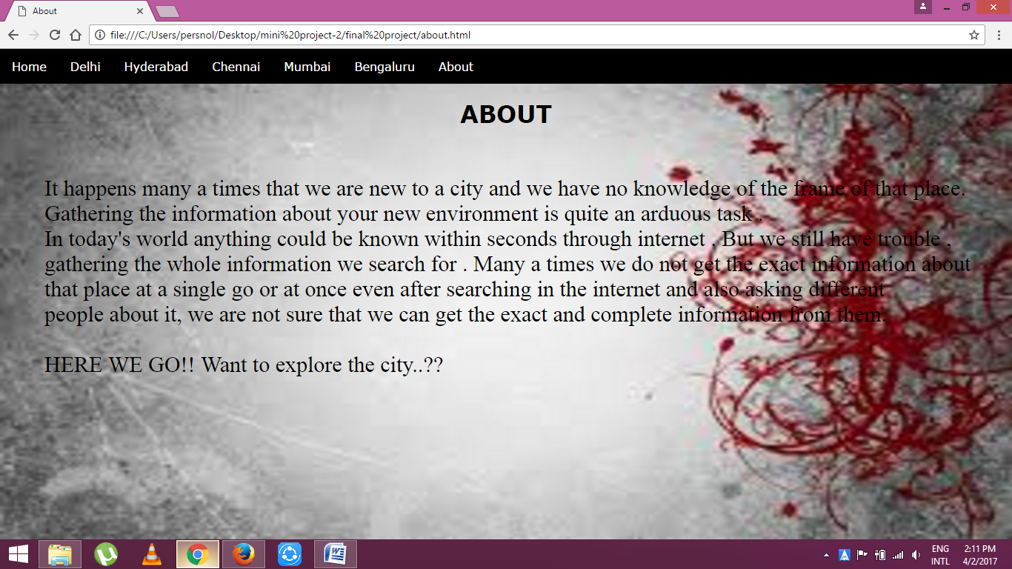

**Chapter 7**

**CONCLUSION**

In this technically developed society we can get any information in internet. But we need to put some efforts to gather exactly required information.

By using this website only a single search provides whole information to the user. Every information such as address, contact number and official website are provided.

**\*REFERENCES**

* <https://www.w3schools.com/html/>
* <https://www.tutorialspoint.com/html/>
* <https://www.w3schools.com/css/>
* <https://www.w3schools.com/howto/default.asp>
* <https://www.google.co.in/search?q=delhi&hl=en&site=webhp&source=lnms&tbm=isch&sa=X&ved=0ahUKEwjMjczdpoXTAhWHso8KHXf7AEMQ_AUICCgD&biw=1366&bih=662>